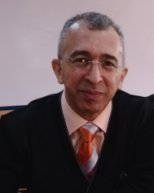
CURRICILUM VITAE
Title and Name: Prof.Dr.İbrahim HAYOĞLU
Place and Date of Birth: Kilis / 1965
Contact İnformation:
Tel: 414.318 3721
Fax: 414. 3183682
e-mail: ihayoglu@harran.edu.tr
Postal Adress: Harran University, Faculty of Engineering, Food Engineering Department, Campus of Osmanbey, Sanliurfa

AREAS of EXPERTISE:
1 | Fruit and Vegetable Processing
2 | Candies and Special Foods
3 | Traditional Foods

EDUCATION:
Degree | Area | University | Year
Ph.D. | Food Eng. Dep. | Çukurova | 1995
M.S. | - Food Eng. Dep. | Çukurova | 1989
B.S. | - Food Science and Tech. Dep. | - Atatürk | 1985

ACADEMIC ASSIGNMENTS:
Job Title | Work Place | Year
Prof.Dr. | Harran University | 2007 - …….
Assoc. Prof.Dr. | Harran University | 2000-2007
Assist. Prof. Dr. | - Harran University | 1996-2000
Res.Assist.Dr. | - Harran University | 1995-1996
Res.Assist. | - Çukurova University | 1987-1995

