**HARRAN UNIVERSITY ENGINEERING FACULTY**

**DEPARTMENT OF FOOD ENDGINEERING**

**CONTENT OF COURSE**

|  |  |  |  |  |  |
| --- | --- | --- | --- | --- | --- |
| **Course Title** | **Code** | **Semester** | **T+U** | **Kredisi** | **ACTS** |
| **Chemistry 1** | 0500102 | 1 | 3+2 | 4 | 6 |
| **Prerequisites** |  | | | | |
| **Course Language** | **Turkish** | | | | |
| **Type of the course** | **Compulsory** | | | | |
| **Course Coordinators** |  | | | | |
| **Lecturer** |  | | | | |
| **Course Assistants** |  | | | | |
| **The aim of the course** | The aim of this course is to give basic chemistry knowledge to the students, to provide the knowledge they have learned in the laboratory environment, to enable them to connect with other subjects from other fields and to produce scientific solutions. | | | | |
|
|
| **Learning Outcomes** | 1 To be able to express the properties of matter and units of measure and to associate periodic properties with atomic structure  2 To be able to express the units and units of matter and to associate the atomic structure with the periodic properties  3 To be able to explain the properties of solids, liquids and gases with molecular interactions, to be able to express solution concentration units,  4 To be able to explain the concepts of speed and equilibrium in chemical reactions, to make calculations in acid-base and ionic equilibrium  5 It is expected to be able to express thermodynamic laws, explain electrochemical equations and related concepts, write core reactions. | | | | |
|
| **Course Content** | In this course, theories of atomic theory, gas, liquid and solid states of matter, solubilizers, chemical thermodynamics, chemical equilibrium, chemical bonds and electrochemistry, basics of atomic theory, chemical laws and stoichiometry, gas, liquid and solid states of matter, Chemical equilibrium, Chemical bonds, Electrochemistry, Cement chemistry issues will be explained. | | | | |
|
|
| **Weeks** | **Topics** | | | | |
| 1) | Properties and measurement of the material | | | | |
| 2) | Atoms and atom theory | | | | |
| 3) | Chemical compounds | | | | |
| 4) | Chemical reactions | | | | |
| 5) | Aqueous solution reactions | | | | |
| 6) | Midterm exam | | | | |
| 7) | Solids | | | | |
| 8) | Gases | | | | |
| 9) | Thermochemistry | | | | |
| 10) | Chemical equilibrium | | | | |
| 11) | Chemical equilibrium | | | | |
| 12) | Electrochemistry, Oxidation-reduction reactions | | | | |
| 13) | Cement Chemistry | | | | |
| 14) | An overview | | | | |
| **General Competences** | In evaluations, it is important for students to understand the main points of this lesson and use it in engineering applications. | | | | |
|
| **References** | *Petrucci, R. H., Harwood, W. S. and Herring, F. G. 2002. General Chemistry; Principles and Modern Applications, Translation Editor: Prof. Dr. Tahsin Uyar and Prof. Dr. Serpil Aksoy, Palme yayıncılık, Ankara.* | | | | |
| *Mortimer, C. E., 1997. Modern University Chemistry, Çağlayan Basımevi, İstanbul.* | | | | |
| *Zumdal, S., 2002. Chemical Principles, 4th Ed., D. C. Heath and Company, Lexington. U.S.A.* | | | | |
| **Evaluation System** | **Midterm exam:% 40 Final exam:% 60** | | | | |
|

|  |  |  |  |  |  |
| --- | --- | --- | --- | --- | --- |
| **Course Title** | **Code** | **Semester** | **T+U** | **Kredisi** | **ACTS** |
| **Chemistry 2** | 0500203 | 2 | 3+2 | 4 | 6 |
| **Prerequisites** |  | | | | |
| **Course Language** | **Turkish** | | | | |
| **Type of the course** | **Compulsory** | | | | |
| **Course Coordinators** |  | | | | |
| **Lecturer** |  | | | | |
| **Course Assistants** |  | | | | |
| **The aim of the course** | The aim of this course is to give basic chemistry knowledge to the students, to provide the knowledge they have learned in the laboratory environment, to connect with the other subjects in the scientific branches and to provide scientific solutions. | | | | |
|
|
| **Learning Outcomes** | 1 Ability to recognize and use devices in general chemistry laboratories  2 To make and understand all kinds of calculations in solution preparation in general chemistry laboratories  3 Having the necessary infrastructure about acids and bases, metals, nonmetals, complex ions and nuclear chemistry.  4 Acquisition of sufficient information on first aid and intervention in all types of laboratory accidents  5 By taking the course, students gain the ability to work in general chemistry laboratories | | | | |
|
| **Course Content** | In this course, acids, bases and equilibria, metals, nonmetals, solubility of compounds, complex-ion balances, coordination chemistry, nuclear and organic chemistry will be explained. | | | | |
|
|
| **Weeks** | **Topics** | | | | |
| 1) | Acids and Bases | | | | |
| 2) | Acid-Base Balances | | | | |
| 3) | Main Group Elements I: Metals | | | | |
| 4) | Main Group Elements I: Metals | | | | |
| 5) | Main Group Elements II: Ametals | | | | |
| 6) | Resolution and Complex-Ion Balances | | | | |
| 7) | Midterm exam | | | | |
| 8) | Resolution and Complex-Ion Balances | | | | |
| 9) | Transition Elements | | | | |
| 10) | Complex Ions and Coordination Compounds | | | | |
| 11) | Complex Ions and Coordination Compounds | | | | |
| 12) | Nuclear Chemistry | | | | |
| 13) | Organic Chemister | | | | |
| 14) | Final exam | | | | |
| **General Competences** | To understand the main topics of the course and use them in practice | | | | |
|
| **References** | 1. Principles of Biochemistry. Lehninger, Nelson – Cox | | | | |
| 1. Saldamlı, İ. 1998. *Gıda Kimyası.* Hacettepe Üniversitesi Yayın., Ankara, 527 sayfa | | | | |
| **Evaluation System** | **Midterm exam:% 40 Final exam:% 60** | | | | |
|

|  |  |  |  |  |  |  |
| --- | --- | --- | --- | --- | --- | --- |
| **Name and code of the course** | | **Code** | **Semester** | **T+P** | **Credit** | **ACTS** |
| **Food Chemistry** | | 0508303 | 3 | 2+0 | 2 | 5 |
| Prerequisite/Recommended | None | | | | | |
| Language of Instruction | Turkish | | | | | |
| Type of the course | Obligatory | | | | | |
| Coordinator of the course | Yrd.Doç.Dr. A.Sabri ÜNSAL | | | | | |
| Instructor | Yrd.Doç.Dr. A.Sabri ÜNSAL | | | | | |
| Assistant of the course |  | | | | | |
| Objective of the course | **:** The aim of this course is to have knowledge of the basic food components of the Food Engineering Department students. | | | | | |
| Learning outputs of the lecture | **At the end of this course students;**   |  | | --- | | Water in the food and its functions  Sorption isotherms, water freezing curves  Chemical structure of carbohydrates, proteins, oils  Vitamins, minerals and other elements of food  It knows abut it | | | | | | |
| Course content | |  | | --- | | What are the chemical structures and functions of proteins, carbohydrates and fats? What are the main constituents in the structure of foods? Investigation of micro elements and trace elements in food | | | | | | |
| **Week** | **Topic** | | | | | |
| 1 | Introduction to Food Chemistry | | | | | |
| 2 | Chemical Bonds | | | | | |
| 3 | Water Chemistry | | | | | |
| 4 | Carbohydrate Chemistry | | | | | |
| 5 | Continue to Carbohydrate Chemistry | | | | | |
| 6 | Lipid Chemistry | | | | | |
| 7 | Midterm Examination | | | | | |
| 8 | Continue to Lipid Chemistry | | | | | |
| 9 | Protein chemistry | | | | | |
| 10 | Continue to Protein Chemistry | | | | | |
| 11 | Enzymes | | | | | |
| 12 | Vitamins and minerals | | | | | |
| 13 | Natural Toxic Materials and Contaminants | | | | | |
| 14 | Food Additives | | | | | |
| **General sufficiency** | | | | | | |
| Understanding the chemical structures of food components. | | | | | | |
| **References** | | | | | | |
| 1. Fennema, O. 1985. *Food Chemistry*. Marcel Dekker Publ., New York, 987 p 2. Saldamlı, İ. 1998. *Gıda Kimyası.* Hacettepe Üniversitesi Yayın., Ankara, 527 p 3. Demirci, M. 1999. *Gıda Kimyası*. Trakya Üniversitesi Yayın., Tekirdağ, 154 p 4. Metin, M. 1998. *Süt Teknolojisi*. Ege Üniversitesi Yayınları, İzmir, 791 p. | | | | | | |
| **Form of Assesment: One written midterm exam (40%) and one written final exam (60%)** | | | | | | |

|  |  |  |  |  |  |  |
| --- | --- | --- | --- | --- | --- | --- |
| **Name and code of the course** | | **Code** | **Semester** | **T+P** | **Credit** | **ACTS** |
| **GENERAL MICROBIOLOGY** | | 0508404 | 4 | 2+2 | 3 | 5 |
| Prerequisite/Recommended | None | | | | | |
| Language of Instruction | Turkish | | | | | |
| Type of the course | Obligatory | | | | | |
| Coordinator of the course | Yrd.Doç.Dr. A.Sabri ÜNSAL | | | | | |
| Instructor | Yrd.Doç.Dr. A.Sabri ÜNSAL, Arş.Gör.Selin Engin ALİHANOĞLU | | | | | |
| Assistant of the course | Arş.Gör.Selin Engin ALİHANOĞLU | | | | | |
| Objective of the course | **:** The aim of this study is teach basic microbiological matters to students that go on license education. | | | | | |
| Learning outputs of the lecture | **At the end of this course students;**   |  | | --- | | End of the this course;  1.Able to provide food conservation methods against microorganisms.  2.Able to provide learn the knowledge about microorganisms | | | | | | |
| Course content | |  | | --- | | Factors effecting on microbial growth.  Patogen bacterias in food.  Conservation methods of food  The effects of antimicrobial substances | | | | | | |
| **Week** | **Topic** | | | | | |
| 1 | Description of microbiology and basic terms | | | | | |
| 2 | Taxonomy of microorganisms and to name of them | | | | | |
| 3 | Introduction of some of important materials and equipment that used in microbiology laboratories | | | | | |
| 4 | Introduction microscope | | | | | |
| 5 | Morphology, sitology and chemical structures of bacteria | | | | | |
| 6 | The structure and reproduction of bacteria | | | | | |
| 7 | Midterm Examination | | | | | |
| 8 | Prevention of microorganisms | | | | | |
| 9 | Prevention of microorganisms by physical methods | | | | | |
| 10 | Prevention of microorganisms by chemical methods | | | | | |
| 11 | Other microorganisms | | | | | |
| 12 | Nutrition of microorganisms, growth and common life formations | | | | | |
| 13 | Chemotherapy and immunity | | | | | |
| 14 | General assessment on topics of microbiology | | | | | |
| **General sufficiency** | | | | | | |
| Have able to fınd solution about the general microbiology problems.  Have able to identify interested topics during the time of education. | | | | | | |
| **References** | | | | | | |
| 1. ÖZDEMİR, S., SERT, S., 2001. Gıda Mikrobiyolojisi Tatbikat Notları. Atatürk Üni. Zir. Fak. Yay. No:228, ERZURUM. 2. SERT, S., 2000. Genel Mikrobiyoloji Atatürk Üni. Zir. Fak. Yay. No:228, ERZURUM. 3. ÖZÇELİK, S., 1998. Genel Mikrobiyoloji. Süleyman Demirel Üni. Zir. Fak. Yay. No:1, ders kitaparı No:1, ISPARTA.statistik Metotları , Ankara Üniv. Ziraat Fak. Yayınları no: 861, Ders Kitapları Yayın No:229, ANKARA. 4. HALKMAN, A.K., 1995. Mikrobiyolojide Kullanılan Besiyerleri, ANKARA. 5. Çakmakçı, M.L., Karahan, A.G., Çakır, İ.(2011) Mikrobiyoloji.Gıda Teknolojisi Derneği Yayınları, No:36, Ankara. | | | | | | |
| **Form of Assesment: One written midterm exam (40%) and one written final exam (60%)** | | | | | | |

|  |  |  |  |  |  |  |
| --- | --- | --- | --- | --- | --- | --- |
| **Name and code of the course** | | **Code** | **Semester** | **T+P** | **Credit** | **ACTS** |
| **Diet and Functional Foods** | | 0508508 | 5 | 2+0 | 2 | 3 |
| Prerequisite/Recommended | None | | | | | |
| Language of Instruction | Turkish | | | | | |
| Type of the course | Optional | | | | | |
| Coordinator of the course | Yrd.Doç.Dr. A.Sabri ÜNSAL, Yrd.Doç.Dr.Çağım Akbulut ÇAKIR | | | | | |
| Instructor | Yrd.Doç.Dr. A.Sabri ÜNSAL, Yrd.Doç.Dr.Çağım Akbulut ÇAKIR | | | | | |
| Assistant of the course |  | | | | | |
| Objective of the course | **:** The aim of this course is; provide students with a general overview of the subjects covered by the Diet and Functional Foods.. | | | | | |
| Learning outputs of the lecture | **At the end of this course students;**   |  | | --- | | Classification of subjects that constitute the content of diet and functional foods and learning basic principles about these subjects. | | | | | | |
| Course content | |  | | --- | | Principles of diet planning, body weight control, behavior modification strategies, nutrition in digestive system diseases, different nutrition groups. | | | | | | |
| **Week** | **Topic** | | | | | |
| 1 | Definition of diet, aim and terminology related to diet | | | | | |
| 2 | Principles of diet planning and nutrition change lists | | | | | |
| 3 | Basic principles in patient nutrition | | | | | |
| 4 | Body weight control | | | | | |
| 5 | Nutrition in digestive system diseases | | | | | |
| 6 | Different nutrition groups | | | | | |
| 7 | Midterm Examination | | | | | |
| 8 | Introduction to Functional food, some definitions of the subject | | | | | |
| 9 | Functional food according to purpose of use | | | | | |
| 10 | Functional foods of plant origin | | | | | |
| 11 | Functional foods of animal origin | | | | | |
| 12 | Functional Food Production Technology | | | | | |
| 13 | Beverage sector and functional innovations | | | | | |
| 14 | The status and future of functional foods in the world and in our country | | | | | |
| **General sufficiency** | | | | | | |
| Ability to recognize the subjects covered by diet and functional foods | | | | | | |
| **References** | | | | | | |
| 1. BAYSAL, A., AKSOY, M., BOZKURT,N., MERDOL, T.K., PEKCAK, G., BESLER, T., KEÇECİOĞLU, S., MERCANLIGİL, S.M., YILDIZ, E., 2008. Diyet El Kitabı, yenilenmiş 5. Baskı, Hatiboğlu. Yay. No: 116, Ankara. 2. TÜRKAN, C., 2007. Turizmde Beslenme İlkeleri ve Mönü Planlama 3. baskı. Detay Yay., ANKARA. 3. GÜVEN, A., GÜLMEZ,M., 2006. Fonksiyonel Gıdalar ve Sağlıkla İlişkisi. Kafkas üni. Vet. Fak. Derg.12(1):91-96, KARS. 4. ROBERFROID, MB, 2000. Prebiotics and Probiotics: Are they functional foods?American J. Clin.Nutr. 71:182-1687. | | | | | | |
| **Form of Assesment: One written midterm exam (40%) and one written final exam (60%)** | | | | | | |

|  |  |  |  |  |  |  |
| --- | --- | --- | --- | --- | --- | --- |
| **Name and code of the course** | | **Code** | **Semester** | **T+P** | **Credit** | **ACTS** |
| **Cereal Technology** | | 0508605 | 6 | 2+2 | 3 | 3 |
| Prerequisite/Recommended | None | | | | | |
| Language of Instruction | Turkish | | | | | |
| Type of the course | Obligatory | | | | | |
| Coordinator of the course | Prof. Dr. Ayhan ATLI / Yrd. Doç.Dr. A. Sabri ÜNSAL | | | | | |
| Instructor | Prof. Dr. Ayhan ATLI / Yrd. Doç.Dr. A. Sabri ÜNSAL | | | | | |
| Assistant of the course |  | | | | | |
| Objective of the course | **:** The aim of this course is; provide students with a general overview of the subjects covered by the Diet and Functional Foods.. | | | | | |
| Learning outputs of the lecture | **At the end of this course students;**   |  | | --- | | 1. Able to provide against cereal products processing technology.  2. Able to know basic principles of cereal products processing technology. | | | | | | |
| Course content | |  | | --- | | General chemical compositions of some of cereals that wheat, barley, rice, corn, oats, sorghums, millets, rye etc.  Quality properties of wheat  Flour milling technology  Bread making technology | | | | | | |
| **Week** | **Topic** | | | | | |
| 1 | In Turkey and the world, the importance of cereal diet related human nutrition , general chemical composition of various cereal grains | | | | | |
| 2 | Nutrient value of some of cereals that wheat, barley, rice, corn, oats, sorghums, millets, rye etc. and general chemical compositions. | | | | | |
| 3 | Ecological, botanical, physical, chemical and technological quality properties of wheat and effective factors over them | | | | | |
| 4 | Cereal properties for suit storage, changes at kernel by storage, different storage methods. | | | | | |
| 5 | The aim of milling, general milling process, relation between flour yield and quality, basic units at mill, prepare for milling of wheat. | | | | | |
| 6 | Conditioning, different conditioning methods, The break and the reduction system. | | | | | |
| 7 | Midterm Examination | | | | | |
| 8 | Flour milling technology and the latest developments | | | | | |
| 9 | The main types of bread and bread making technology | | | | | |
| 10 | The basic bread defects and diseases. The basic principles of bread conservation | | | | | |
| 11 | Bulghur processing technology | | | | | |
| 12 | Biscuit processing technology | | | | | |
| 13 | Pasta processing technology | | | | | |
| 14 | Breakfast cereal products | | | | | |
| **General sufficiency** | | | | | | |
| -Have able to provide against cereal products processing technology.  - Have able to identify interested topics during the time of education | | | | | | |
| **References** | | | | | | |
| 1. ELGÜN, A., ERTUGAY, Z., 1992. Tahıl İşleme Teknolojisi, Atatürk Üni. Yay. No: 718, Erzurum. 2. POMERANZ, Y., 1988. GWheat Chemistry and Technology. Third Ed. Vol 1, USA. 3. POMERANZ, Y., 1988. GWheat Chemistry and Technology. Third Ed. Vol 2, USA. | | | | | | |
| **Form of Assesment: One written midterm exam (40%) and one written final exam (60%)** | | | | | | |

|  |  |  |  |  |  |  |
| --- | --- | --- | --- | --- | --- | --- |
| **Name and code of the course** | | **Code** | **Semester** | **T+P** | **Credit** | **ACTS** |
| **Nutrition** | | 0508609 | 6 | 2+0 | 2 | 3 |
| Prerequisite/Recommended | None | | | | | |
| Language of Instruction | Turkish | | | | | |
| Type of the course | Optional | | | | | |
| Coordinator of the course | Yrd. Doç.Dr. A. Sabri ÜNSAL | | | | | |
| Instructor | Yrd. Doç.Dr. A. Sabri ÜNSAL | | | | | |
| Assistant of the course |  | | | | | |
| Objective of the course | The objective of this course is to acquaint the students with fundamental concepts of nutrition, and to familiarize them the importance of nutrition in food science. | | | | | |
| Learning outputs of the lecture | **At the end of this course students;**   |  | | --- | | Have an adequate knowledge of nutrition principles. | | | | | | |
| Course content | |  | | --- | | -quality concept, food quality control and related definitions;  -national and international standards  -Nutrition and relation with health | | | | | | |
| **Week** | **Topic** | | | | | |
| 1 | Define of nutrition and relation with health | | | | | |
| 2 | Structural period of nutrition | | | | | |
| 3 | Metabolism and some basic terms and nutrients | | | | | |
| 4 | Carbohydrates (1) | | | | | |
| 5 | Carbohydrates (2) | | | | | |
| 6 | Proteinler (1) | | | | | |
| 7 | Midterm Examination | | | | | |
| 8 | Proteinler (2) | | | | | |
| 9 | Lipids (1) | | | | | |
| 10 | Lipids (2) | | | | | |
| 11 | Energy metabolism | | | | | |
| 12 | Nucleic acids, enzymes and hormones | | | | | |
| 13 | Vitamins and minerals | | | | | |
| 14 | General assessment on topics of nutrition principles | | | | | |
| **General sufficiency** | | | | | | |
| - Able to be familier with nutrition principles.  - Able to know topics and lectures related with the Nutrition Principles | | | | | | |
| **References** | | | | | | |
| 1. 1. BAYSAL, A., 1983. Beslenme. H.Ü. Yay. A/13, ANKARA. 2. 2. KESKİN, H., 1987. Besin Kimyası. İ.Ü. Müh. Fak. Yay. No:72, cilt:1, İSTANBUL. 3. 3. KESKİN, H., 1987. Besin Kimyası. İ.Ü. Müh. Fak. Yay. No:72, cilt:2, İSTANBUL 4. 4. DEMİRCİ, M., ALPASLAN, M., 1994. Gıda Kimyası , Trakya Üni. Tekirdağ Zir. Fak. Yay. No: 39, ders notu:38, TEKİRDAĞ. | | | | | | |
| **Form of Assesment: One written midterm exam (40%) and one written final exam (60%)** | | | | | | |

|  |  |  |  |  |  |  |
| --- | --- | --- | --- | --- | --- | --- |
| **Name and code of the course** | | **Code** | **Semester** | **T+P** | **Credit** | **ACTS** |
| **Bread and the bread types** | | 0508805 | 8 | 2+0 | 2 | 3 |
| Prerequisite/Recommended | None | | | | | |
| Language of Instruction | Turkish | | | | | |
| Type of the course | Optional | | | | | |
| Coordinator of the course | Yrd. Doç.Dr. A. Sabri ÜNSAL | | | | | |
| Instructor | Yrd. Doç.Dr. A. Sabri ÜNSAL | | | | | |
| Assistant of the course |  | | | | | |
| Objective of the course | For undergraduate students:  Bread technology is to popularize,  General information about the topics covered in bread technology to gain meaningful information. | | | | | |
| Learning outputs of the lecture | **At the end of this course students;**   |  | | --- | | Classification of topics that constitute bread technology and  learning the basic principles of these subjects | | | | | | |
| Course content | |  | | --- | | -The history of bread  -The role of bread in nutrition  - Main bread making methods and types of bread | | | | | | |
| **Week** | **Topic** | | | | | |
| 1 | Bread, description and history | | | | | |
| 2 | Bread for human nutrition | | | | | |
| 3 | Basic materials used in bread making, properties related to flour | | | | | |
| 4 | Basic materials used in bread making, properties related to yeast | | | | | |
| 5 | Basic materials used in bread making, properties of water and salt | | | | | |
| 6 | Other materials used in bread making | | | | | |
| 7 | Midterm Examination | | | | | |
| 8 | Baking, kneading and fermentation stages | | | | | |
| 9 | Baking of bread and main bakery types | | | | | |
| 10 | Factors affecting bread flavor and bread crust color formation | | | | | |
| 11 | The main dough preparation methods | | | | | |
| 12 | Bread defects and diseases | | | | | |
| 13 | The main bread types, loaf bread | | | | | |
| 14 | The main bread types, flat bread | | | | | |
| **General sufficiency** | | | | | | |
| Ability to recognize baking topics | | | | | | |
| **References** | | | | | | |
| 1. 1. ELGÜN, A., ERTUGAY, Z., 1992. Tahıl İşleme Teknolojisi, Atatürk Üni. Yay. No: 718, Erzurum. 2. 2. BAYSAL, A., 1983. Beslenme. H.Ü. Yay. A/13, ANKARA. 3. 3. ELGÜN, A., TÜRKER,S., BİLGİÇLİ, N., 2012. Tahıl Ürünleri Teknolojisi, Konya. | | | | | | |
| **Form of Assesment: One written midterm exam (40%) and one written final exam (60%)** | | | | | | |

|  |  |  |  |  |  |  |
| --- | --- | --- | --- | --- | --- | --- |
| **Name and code of the course** | | **Code** | **Semester** | **T+P** | **Credit** | **ACTS** |
| **Flour Milling Technology** | | 0508806 | 8 | 2+0 | 2 | 3 |
| Prerequisite/Recommended | None | | | | | |
| Language of Instruction | Turkish | | | | | |
| Type of the course | Optional | | | | | |
| Coordinator of the course | Yrd. Doç.Dr. A. Sabri ÜNSAL | | | | | |
| Instructor | Yrd. Doç.Dr. A. Sabri ÜNSAL | | | | | |
| Assistant of the course |  | | | | | |
| Objective of the course | The aim of this course is; to provide students with an undergraduate education an overview of the topics covered in the grinding of cereals. | | | | | |
| Learning outputs of the lecture | **At the end of this course students;**   |  | | --- | | Classification of the subjects that constitute the grain grinding content and learning the basic principles of these subjects | | | | | | |
| Course content | |  | | --- | | Relationship between grains and nutrition, chemical and anatomical structure of wheat, storage of cereals, intentional and principal milling operations, packaging of flour | | | | | | |
| **Week** | **Topic** | | | | | |
| 1 | Information about grains in general | | | | | |
| 2 | The importance of grain for nutrition | | | | | |
| 3 | Anatomical structure of wheat | | | | | |
| 4 | Explanation of yield and quality concepts, comparison of the gluten-forming abilities of some cereal proteins | | | | | |
| 5 | Chemical structure of wheat | | | | | |
| 6 | Grain storage | | | | | |
| 7 | Midterm Examination | | | | | |
| 8 | Grain formation stages in wheat | | | | | |
| 9 | Wheat quality criteria | | | | | |
| 10 | Purpose of the milling, major milling operations | | | | | |
| 11 | Introducing the main units of flour milling | | | | | |
| 12 | Conditioning | | | | | |
| 13 | Grinding, vals and working principles | | | | | |
| 14 | Recent developments in flour milling, packaging of flour | | | | | |
| **General sufficiency** | | | | | | |
| Ability to recognize the topics covered in cereal grinding technology | | | | | | |
| **References** | | | | | | |
| 1. 1. ELGÜN, A., ERTUGAY, Z., 1992. Tahıl İşleme Teknolojisi, Atatürk Üni. Yay. No: 718, Erzurum. 2. 2. ÖZKAYA, H., ÖZKAYA, B., 2005. Öğütme Teknolojisi. Gıda Tekn. Derneği Yay. No 30, ANKARA. | | | | | | |
| **Form of Assesment: One written midterm exam (40%) and one written final exam (60%)** | | | | | | |

|  |  |  |  |  |  |  |  |
| --- | --- | --- | --- | --- | --- | --- | --- |
| **Name of the Course:** | | | **Code** | **Semester** | **T+P** | **Credit** | **ACTS** |
| Basic Operations I | | | 0508502 | 5 | 3+0 | 3 | 5 |
| **Requirements** | | | - | | | | |
| **Language of the course** | | Turkish | | | | | |
| **Type of the course** | | Obligatory | | | | | |
| **Coordinator of the course** | | Prof.Dr.İbrahim HAYOĞLU | | | | | |
| **Lecturer** | | Prof.Dr.İbrahim HAYOĞLU; Prof.Dr.Ferit ATASOY | | | | | |
| **Co lecturers** | |  | | | | | |
| **Aim of the course** | | The aim of this lecture is to give information about basic operations especially necessary for food processing, and establish a background to solve problems encountered in industry. | | | | | |
| **Learning outputs of the lecture** | | End of the this course; the students will acquire information about basic operations and equipment in food industry, to understand problems and gain skill to develop solutions. In addition, provide experience of laboratory applications. | | | | | |
| **Course content** | | Selection of convenient raw material, quality criteria, basic operations applied in food industry such as cleaning and sorting out, and classification, reduction of size, centrifugation, and their basic principles. | | | | | |
| **Weeks** | **Topics** | | | | | | |
| **1** | Introduction and Basic Units in Food Engineering | | | | | | |
| **2** | Raw Materials and some properties | | | | | | |
| **3** | Cleaning of raw materials | | | | | | |
| **4** | Sorting and sizing of Foods | | | | | | |
| **5** | Grading of Foods | | | | | | |
| **6** | Peeling of Foods | | | | | | |
| **7** | Interim Exam | | | | | | |
| **8** | Size Reduction | | | | | | |
| **9** | Screening | | | | | | |
| **10** | Mixing | | | | | | |
| **11** | Emulsification | | | | | | |
| **12** | Filtration | | | | | | |
| **13** | Membrane Separation | | | | | | |
| **14** | Centrifugation | | | | | | |
| **General sufficiency** | | | | | | | |
| Students acquire necessary knowledge and get familiarized with applications in food industry, and get himself/herself prepared to work in this area. | | | | | | | |
| **References** | | | | | | | |
| BRENNAN, J.G., BUTTERS, J.R., COWELL, N.D., LİLLEY, A.E.V., 1990. *Food Engineering Operations. (third edition).* Elsevier applied sci. LONDON and NEW YORK  FELLOWS, P.J., 1992. *Food Processing Technology: principles and practice.* Ellis Horwood, NEW YORK, LONDON. | | | | | | | |
| **Evaluation system** | | | | | | | |
| Interim exam: 40%, Final: 60% | | | | | | | |

|  |  |  |  |  |  |  |
| --- | --- | --- | --- | --- | --- | --- |
| **Name of the Course:** | | **Code** | **Semester** | **T+P** | **Credit** | **ACTS** |
| Fermentation Technology | | 0508506 | 5 | 2+0 | 2 | 3 |
| **Requirements** | | - | | | | |
| **Language of the course** | | Turkish | | | | |
| **Type of the course** | | Elective | | | | |
| **Coordinator of the course** | | Prof.Dr.İbrahim HAYOĞLU | | | | |
| **Lecturer** | | Prof.Dr.İbrahim HAYOĞLU | | | | |
| **Co lecturers** | | - | | | | |
| **Aim of the course** | | The aim of this lecture is to give information about fermentation and fermented foods, and ensure that they can use appropriate methods to evaluate fermented foods | | | | |
| **Learning outputs of the lecture** | | This course enables students to have knowledge about the production of fermented food, understand the problems of the industry and produce solutions. In the sector, production is oriented in its applications and gives experience in quality evaluation. | | | | |
| **Course content** | | Fermented foods; production, evaluation, nutritional values, stabilization and preservation processes. | | | | |
| **Weeks** |  | | | | | |
|  | Introduction to fermentation technology and basic concepts | | | | | |
|  | Aerob and anaerob breath metabolism | | | | | |
|  | Microorganisms involved in fermentation (yeast, bacteria and molds) | | | | | |
|  | Beer raw materials and hops | | | | | |
|  | Malting and brewing | | | | | |
|  | Types of beer, defects and diseases | | | | | |
|  | Interim Exam | | | | | |
|  | Grape varieties of wine and wine making methods | | | | | |
|  | Types of wines , wine defects and diseases | | | | | |
|  | Vinegar production | | | | | |
|  | Vinegar production | | | | | |
|  | Pickle production | | | | | |
|  | Pickle production | | | | | |
|  | Other fermented foods and production techniques (Boza, Şalgam, ..etc.) | | | | | |
| **General sufficiency** | | | | | | |
| Students acquire necessary knowledge and get familiarized with applications in fermented food industry, and get himself / herself prepared to work in this area. | | | | | | |
| References | | | | | | |
| Akman A., Yazıcıoğlu T. 1999. Fermantasyon Teknolojisi, Ankara Üniv. Ziraat Fakültesi Yayınları.  Arıcı M.  Aktan N., Yıldırım Y. 2011. Sirke Teknolojisi (3. Baskı). Sidas Medya. İzmir. | | | | | | |
| **Evaluation system:** Interim exam: 40%, Final: 60% | | | | | | |

|  |  |  |  |  |  |  |  |
| --- | --- | --- | --- | --- | --- | --- | --- |
| **Name of the Course:** | | | **Code** | **Semester** | **T+P** | **Credit** | **ACTS** |
| Basic Operations II | | | 0508602 | 6 | 3+0 | 3 | 5 |
| **Requirements** | | | - | | | | |
| **Language of the course** | | Turkish | | | | | |
| **Type of the course** | | Obligatory | | | | | |
| **Coordinator of the course** | | Prof.Dr.İbrahim HAYOĞLU | | | | | |
| **Lecturer** | | Prof.Dr.İbrahim HAYOĞLU; Prof.Dr.Ferit ATASOY | | | | | |
| **Co lecturers** | |  | | | | | |
| **Aim of the course** | | The aim of this lecture is to give information about basic operations especially necessary for food processing, and establish a background to solve problems encountered in industry. | | | | | |
| **Learning outputs of the lecture** | | End of the this course; the students will acquire information about basic operations and equipment in food industry, to understand problems and gain skill to develop solutions. In addition, provide experience of laboratory applications. | | | | | |
| **Course content** | | Selection of convenient raw material, quality criteria, basic operations applied in food industry such as cleaning and sorting out, and classification, reduction of size, centrifugation, and their basic principles. | | | | | |
| **Weeks** | **Topics** | | | | | | |
| **1** | Extraction process | | | | | | |
| **2** | Pressing process | | | | | | |
| **3** | Crystallization | | | | | | |
| **4** | Ionization of foodstuff | | | | | | |
| **5** | Thermal processing | | | | | | |
| **6** | Boiling (scalding) | | | | | | |
| **7** | Interim exam | | | | | | |
| **8** | Pasteurization | | | | | | |
| **9** | Sterilization | | | | | | |
| **10** | Evaporation | | | | | | |
| **11** | Dehydration | | | | | | |
| **12** | Microwave application in food industries | | | | | | |
| **13** | cooling | | | | | | |
| **14** | storage | | | | | | |
| **General sufficiency** | | | | | | | | |
| * Students acquire necessary knowledge and get familiarized with applications in food industry, and get himself / herself prepared to work in this area. | | | | | | | | |
| References | | | | | | | | |
| BRENNAN, J.G., BUTTERS, J.R., COWELL, N.D., LİLLEY, A.E.V., 1990. *Food Engineering Operations. (third edition).* Elsevier applied sci. LONDON and NEW YORK  FELLOWS, P.J., 1992. *Food Processing Technology: principles and practice.* Ellis Horwood, NEW YORK, LONDON. | | | | | | | | |
| **Evaluation system** | | | | | | | |
| Interim exam: 40%, Final: 60% | | | | | | | |

|  |  |  |  |  |  |  |  |  |
| --- | --- | --- | --- | --- | --- | --- | --- | --- |
| **Name of the Course:** | | | | **Code** | **Semester** | **T+P** | **Credit** | **ACTS** |
| Fruit -Vegetable Technology | | | | 0508604 | 6 | 2+2 | 3 | 3 |
| **Requirements** | | | - | | | | | |
| **Language of the course** | | Turkish | | | | | | |
| **Type of the course** | | Obligatory | | | | | | |
| **Coordinator of the course** | | Prof.Dr.İbrahim HAYOĞLU | | | | | | |
| **Lecturer** | | Prof.Dr.İbrahim HAYOĞLU | | | | | | |
| **Co lecturers** | |  | | | | | | |
| **Aim of the course** | | The students will be provided with the basic knowledge about harnessing methods for fruits and vegetables, and skill to solve the possible problems in industry. | | | | | | |
| **Learning outputs of the lecture** | | This lecture enables the students to understand the basic operations of processing of fruits and vegetables, and to understand the problems of this industry. It also enables the students to develop the skills in laboratory and quality evaluation. | | | | | | |
| **Course content** | | Nutritional values of fruits and vegetables, processing, storage, and preservation processes. | | | | | | |
| **Weeks** | **Subjects** | | | | | | | |
| **1** | Compozition and Nutritional value of Fruits and vegetables | | | | | | | |
| **2** |
| **3** | Spoilage of Fruits and vegetables | | | | | | | |
| **4** | Preservation methods of fruits and vegetables | | | | | | | |
| **5** | Storage of fruits and vegetable under cold conditions | | | | | | | |
| **6** | Freeze-storage of fruits and vegetables | | | | | | | |
| **7** | Interim exam | | | | | | | |
| **8** | Canning technology | | | | | | | |
| **9** |
| **10** | Production process of tomato paste | | | | | | | |
| **11** | Sterilization | | | | | | | |
| **12** | Production process of jam, marmalade and jellies. | | | | | | | |
| **13** | Drying and dehydration process of fruits and vegetables | | | | | | | |
| **14** | Production of juice | | | | | | | |
| **General sufficiency** | | | | | | | | |
| Students acquire necessary knowledge and get familiarized with applications in fruit and vegetable processing industry, and get himself / herself prepared to work in this area. | | | | | | | | |
| **References** | | | | | | | | |
| CEMEROĞLU, B., ACAR, J. 1986, *Meyve ve Sebze İşleme Teknolojisi. Gıda Teknolojisi Derneği Y.No:6. ANKARA*  CEMEROĞLU, B., KARADENİZ, F., ÖZKAN, M. 2003. *Meyve ve Sebze İşleme Teknolojisi. Gıda Teknolojisi Derneği Y.No:28. ANKARA* | | | | | | | | |
| **Evaluation system** | | | | | | | | |
| Interim exam: 40%, Final: 60% | | | | | | | | |

|  |  |  |  |  |  |  |  |  |
| --- | --- | --- | --- | --- | --- | --- | --- | --- |
| **Name of the course** | | | | **Code** | **Term** | **T + P** | **Credit** | **ECTS** |
| Sensory Evaluation Technics of Foods | | | | 0508610 | 6 | 2+0 | 2 | 4 |
| **Course Prerequisite** | |  | | | | | | |
| **Type of the course** | | | **Elective** | | | | | |
| **Name of the instructor who taught the course last semester** | | | **Prof.Dr.İbrahim HAYOĞLU** | | | | | |
| **Aim and goals of the course** | | | To give some information to students about sensory evaluation, and training them to evaluate food using appropriate method. | | | | | |
| **Contents of the course** | | | Evaluation some foods with respect to taste, flavor, aroma and texture, evaluation methods, factors affecting sensory analysis. | | | | | |
| **Weeks** | **Semester Teaching Plan** | | | | | | | |
| **1.** | The basic concepts of food quality control | | | | | | | |
| **2.** | Sensory characteristics of foods | | | | | | | |
| **3.** | Appearance characteristics of food | | | | | | | |
| **4.** | Color, kinesthetic and taste properties of foods | | | | | | | |
| **5.** | Sensory testing laboratory | | | | | | | |
| **6.** | Determination of purpose and selection of the method | | | | | | | |
| **7.** | Midterm exam. | | | | | | | |
| **8.** | selection and training of panelist | | | | | | | |
| **9.** | Sensory testing techniques | | | | | | | |
| **10.** | difference tests | | | | | | | |
| **11.** | Ranking tests | | | | | | | |
| **12.** | Application of sensory tests | | | | | | | |
| **13.** | evaluation of results | | | | | | | |
| **14.** | Preparation and implementation of tests | | | | | | | |
| **References** | | | | | | | | |
| Altuğ, T. 1993. Duyusal test teknikleri. E.Ü. Müh. Fak. No:28. İzmir.  Altuğ, T., Ova ,G., Demirağ, K. ve Kurtcan, Ü. 1995. Gıda kalite kontrolü. E.Ü. Müh. Fak. No:29. İzmir.  Gould, V.A. 1977. Food quality assurance. AVİ. Pub. Co.İnc.USA. | | | | | | | | |
| **Evaluation** | | | | | | | | |
| Interim exam: 40%, Final: 60% | | | | | | | | |

|  |  |  |  |  |  |  |  |  |
| --- | --- | --- | --- | --- | --- | --- | --- | --- |
| **Name of the course** | | | | **Code** | **Term** | **T + P** | **Credit** | **ECTS** |
| Fruit juice and Technology | | | | 0508711 | 7 | 2+0 | 2 | 3 |
| **Course Prerequisite** | |  | | | | | | |
| **Type of the course (Obligatory/Elective)** | | | **Elective** | | | | | |
| **Name of the instructor who taught the course last semester** | | | **Prof.Dr.İbrahim HAYOĞLU** | | | | | |
| **Aim and goals of the course** | | | To give some information about production of fruit juice and introduction of the new processing technology to student. | | | | | |
| **Contents of the course** | | | Nutrition content of fruits and its processing, production and preservation of fruit juices. | | | | | |
| **Weeks** | **Semester Teaching Plan** | | | | | | | |
|  | The main characteristics of fruits | | | | | | | |
|  | Preparation of fruits for processing | | | | | | | |
|  | Pre-treatment for pressing | | | | | | | |
|  | Obtain of pulp | | | | | | | |
|  | Pressing and pressing systems | | | | | | | |
|  | Clarification and filtration | | | | | | | |
|  | Midterm exam | | | | | | | |
|  | Filter aids and the filters | | | | | | | |
|  | Concentration of fruit juice | | | | | | | |
|  | Evaporation and evaporators. | | | | | | | |
|  | Recovery of aroma | | | | | | | |
|  | Preparation of fruit juice and nectars to filling | | | | | | | |
|  | Packaging of fruit juice and nectars | | | | | | | |
|  | Processing of some fruits to fruit juices | | | | | | | |
| **References** | | | | | | | | |
| Cemeroğlu, B., Karadeniz,F., 2001. Meyve suyu Üretim Teknolojisi. Gıda Tek.Der. Y.no:25.  Varnam, H.A. and Sutherland, J.P., 1994. Beverages. Chapman & Hall. UK  Acar, J. 1988. Meyve ve sebze suyu üretim teknolojisi. H.Ü. Ankara | | | | | | | | |
| **Evaluation** | | | | | | | | |
| Interim exam: 40%, Final: 60% | | | | | | | | |

|  |  |  |  |  |  |  |  |  |
| --- | --- | --- | --- | --- | --- | --- | --- | --- |
| **Name of the Course:** | | | | **Code** | **Semester** | **T+P** | **Credit** | **ACTS** |
| Technology of Special Foods | | | | 0508713 | 7 | 2+0 | 2 | 3 |
| **Requirements** | | - | | | | | | |
| **Language of the course** | | | Turkish | | | | | |
| **Type of the course** | | | Elective | | | | | |
| **Coordinator of the course** | | | Prof.Dr.İbrahim HAYOĞLU | | | | | |
| **Lecturer** | | | Prof.Dr.İbrahim HAYOĞLU | | | | | |
| **Co lecturers** | | |  | | | | | |
| **Aim of the course** | | | The students will be provided with the basic knowledge about production process of sugar, cacao, chocolate, candy, tea and coffee, and the skill to solve the possible problems in industry. | | | | | |
| **Learning outputs of the lecture** | | | This lecture enables the students to understand the production process of sugar, cacao, chocolate, candy, tea and coffee, and to understand the problems of this industry. | | | | | |
| **Course content** | | | Processing of sugar, cacao, chocolate, candy, tea and coffee, and their storage. | | | | | |
| **Weeks** | **Subjects** | | | | | | | |
| **1** | Sugar Technology | | | | | | | |
| **2** |
| **3** | Production of Glucose syrup | | | | | | | |
| **4** | Cacao and Chocolate technology | | | | | | | |
| **5** |
| **6** | Candy Technology | | | | | | | |
| **7** | Interim exam | | | | | | | |
| **8** | Production and packaging of candy | | | | | | | |
| **9** | Marsmelovs, nougat, Starch and pectin jelies | | | | | | | |
| **10** |
| **11** | Hard Candies | | | | | | | |
| **12** | Tea Processing and Technology | | | | | | | |
| **13** |
| **14** | Coffee Technology | | | | | | | |
| **General sufficiency** | | | | | | | | |
| At the end of the lecture, students acquire necessary knowledge and get familiarized with sugar, cacao, chocolate, candy, tea and coffee processing industry, and get himself / herself prepared to work in this area. | | | | | | | | |
| **References** | | | | | | | | |
| ALTAN, A., 2005, *Özel Gıdalar Teknolojisi.* Çukurova Üniversitesi Ziraat Fakültesi. Ders kitabı no: 101.ADANA | | | | | | | | |
| **Evaluation system** | | | | | | | | |
| Interim exam: 40%, Final: 60% | | | | | | | | |

|  |  |  |  |  |  |  |  |  |
| --- | --- | --- | --- | --- | --- | --- | --- | --- |
| **Name of the course** | | | | **Code** | **Term** | **T + P** | **Credit** | **ECTS** |
| Olive Processing Technology | | | | 0508814 | 8 | 2+0 | 2 | 3 |
| **Course Prerequisite** | |  | | | | | | |
| **Type of the course (Obligatory/Elective)** | | | **Elective** | | | | | |
| **Name of the instructor who taught the course last semester** | | | **Prof.Dr.İbrahim HAYOĞLU** | | | | | |
| **Aim and goals of the course** | | | To give some information to students about olive and olive oil types, their compositions, and introduction of new production technologies | | | | | |
| **Contents of the course** | | | Nutritional value of the olive and olive oil, processing procedures for obtaining and preservation of olive oil. | | | | | |
| **Weeks** | **Semester Teaching Plan** | | | | | | | |
| **1.** | Olive Cultivation in the World and in Turkey | | | | | | | |
| **2.** | Important olive varieties and specifications of our country | | | | | | | |
| **3.** | Olive harvesting and processing systems | | | | | | | |
| **4.** | Removing methods of Olive bitterness | | | | | | | |
| **5.** | Processing and storage of olives | | | | | | | |
| **6.** |
| **7.** | Midterm exam | | | | | | | |
| **8.** | The chemical structure of the olive oil | | | | | | | |
| **9.** | Minor components of olive oil | | | | | | | |
| **10.** | The olive oil production and oil production methods | | | | | | | |
| **11.** | Refining of olive oil | | | | | | | |
| **12.** | Olive oil deterioration and defects | | | | | | | |
| **13.** |
| **14.** | Olive pomace and its usage | | | | | | | |
| **References** | | | | | | | | |
| Özilbey, N. 2011. Zeytin Çeşitlerimiz. Sidas Medya Ltd. Şti. İzmir.  Göğüş, F., Özkaya, M.T., Ötleş, S. Zeytinyağı. Eflatun Yayınevi. Ankara.  Kayahan, M. 2005. Yemeklik Yağ Rafinasyon Teknolojisi. TMMOB Gıdan Müh. Odası. Ankara.  Kayahan, M. 2003. Yağ kimyası. ODTÜ Yayıncılık. Ankara.  Nas, S., Gökalp, H.Y., Ünsal, M., 1992. Bitkisel Yağ Teknolojisi. Atatürk Ün. Y.No: 723. Erzurum | | | | | | | | |
| **Evaluation** | | | | | | | | |
| One written midterm exam (40%), one written final exam (%60). | | | | | | | | |

|  |  |  |  |  |  |
| --- | --- | --- | --- | --- | --- |
| **Name of the Course:** | **Code** | **Semester** | **T+P** | **Credit** | **ACTS** |
| Dairy Technology | 0508504 | 5 | 2 + 2 | 3 | 3 |
| Requirements | - | | | | |
| Language of the course | Turkish | | | | |
| Type of the course | Obligatory | | | | |
| Coordinator of the course |  | | | | |
| Lecturer | Professor Dr. Mutlu Buket AKIN | | | | |
| Co lecturers |  | | | | |
| Aim of the course | Aim of the course is to explain milk composition and dairy products, and to teach the importance of dairy technology in food industry to undergraduate students. | | | | |
|
|
| Learning outputs of the lecture | **End of the this course;**   1. Understand to dairy chemistry and biochemistry 2. Able to learn dairy processing and 3. . Able to learn production of dairy products | | | | |
|
| Course content | Production of milk, dairy chemistry, microorganisms and enzymes in milk, collection and reception of milk, designing of process line, equipments in dairy industry, building-blocks of dairy processing, sterilization, production of starter cultures, membrane techniques, production of some dairy products and practices, whey processing, cleaning of dairy equipments, quality control of raw milk and dairy products, sensory analysis, artifices and defects in dairy products. | | | | |
|
|
| **Week** | **Topic** | | | | |
| 1 | Define of milk, composition of milk and physical properties of milk | | | | |
| 2 | Milk lipids and nitrogenous compounds | | | | |
| 3 | Lactose and mineral matters | | | | |
| 4 | Enzymes in milk, minor compounds and contaminants in milk | | | | |
| 5 | Microorganisms in milk | | | | |
| 6 | Collection and reception of milk | | | | |
| 7 | Interim exam | | | | |
| 8 | Technological process in milk | | | | |
| 9 | Heating process in milk | | | | |
| 10 | Drinking milk technology | | | | |
| 11 | Cheese technology | | | | |
| 12 | Yogurt and fermented milk technologies | | | | |
| 13 | Butter production technology | | | | |
| 14 | Ice cream production technology | | | | |
| **General sufficiency** | In evaluations it is important to understand the main points of this lesson for students and use it in engineering applications | | | | |
| **References** | **1. ÜÇÜNCÜ, M. 2005.** Süt ve Mamulleri Teknolojisi. Meta Basım ve Matbaacılık Hizmetleri. İzmir.  2. **GOFF, H. D., 2005.** Dairy Science and technology Guelph Universitesi Ders Notları (www. foodsci. uoguelph.ca/dairy.edu)  3. **ÜÇÜNCÜ, M. 2002.** Süt Teknolojisi (II. Bölüm). E. Ü. Mühendislik Fakültesi Yayınları No: 32 E. Ü. Basımevi Bornova, İzmir.  4. **KONAR, A., 1998.** Süt Teknolojisi. Ç. Ü. Ziraat Fakültesi Genel Yayın No: 140 Ders Kitapları  Yayın No: A-45, Adana.  5. **METİN, M., 1996.** Süt Teknolojisi. E. Ü. Mühendislik Fakültesi Yayınları No: 33. E. Ü. Basımevi Bornova, İzmir.  6. **YETİŞMEYEN, A.,1995.** Süt Teknolojisi. Ankara Üniv. Zir. Fak. Yayın No: 1420 Ders Kitabı: 410, Ankara.  7. Bylund, Gösta, 1995. Dairy Processing Handbook TetraPak Processing Systems AB S-221 86 Lund, Sweden | | | | |
| **Evaluation system** | **Interim exam: 40% Final: 60%** | | | | |

|  |  |  |  |  |  |
| --- | --- | --- | --- | --- | --- |
| **Name of the Course:** | **Code** | **Semester** | **T+P** | **Credit** | **ACTS** |
| Presentation Techniques Supported with Computer | 0508608 | 6 | 2 + 0 | 2 | 3 |
| Requirements | - | | | | |
| Language of the course | Turkish | | | | |
| Type of the course | Elective | | | | |
| Coordinator of the course |  | | | | |
| Lecturer | Professor Dr. Mutlu Buket AKIN | | | | |
| Co lecturers |  | | | | |
| Aim of the course | Aim of the course is to explain efective presentation techniques and to teach presentation techniques supported with PC to undergraduate students. | | | | |
|
|
| Learning outputs of the lecture | **End of the this course;**   1. Understand to communication 2. Able to learn effective presentation techniques and   . Able to learn preparing presentation by using PC | | | | |
|
| Course content | * Communication, body language, preparing a presentation by using power point programme in PC | | | | |
|
|
| **Week** | **Topic** | | | | |
| 1 | Introduction | | | | |
| 2 | Effective presentation techniques | | | | |
| 3 | Preparation for presentation | | | | |
| 4 | Choosing and using equipments for presentation | | | | |
| 5 | Designing of a presantation | | | | |
| 6 | What should be done for effective presentation? | | | | |
| 7 | Interim exam | | | | |
| 8 | What shouldn’t be done for effective presentation? | | | | |
| 9 | What should be done after presentation? What are correct or/and incorrect in a presentation | | | | |
| 10 | Practice | | | | |
| 11 | Practice | | | | |
| 12 | Practice | | | | |
| 13 | Practice | | | | |
| 14 | Practice | | | | |
| **General sufficiency** | In evaluations it is important to understand the main points of this lesson for students and use it in engineering applications | | | | |
| **References** | 1. Etkili Sunuş Teknikleri.2006. [www.bilkent.edu.tr](http://www.bilkent.edu.tr/)  2. Güneş, Z., 2005. Etkili sunum teknikleri. 18. Ulusal farmakoloji Kongresi.  3. SEFEROĞLU, S.  S., 2006. Etkili Sunuş Teknikleri. www.bote.ogu.edu.tr/haberler.aspx?id=83  4. KARAYURT, Ö.,  AVCI, İ. A., 2006. Sözel Sunum Teknikleri. [www.saglik.gov.tr](http://www.saglik.gov.tr/)  5. TOKAY, D., 2004. Etkili Sunum Teknikleri. www.sabanciuniv.edu/ | | | | |
| **Evaluation system** | **Interim exam: 40% Final: 60%** | | | | |

|  |  |  |  |  |  |
| --- | --- | --- | --- | --- | --- |
| **Name of the Course:** | **Code** | **Semester** | **T+P** | **Credit** | **ACTS** |
| Food Packaging | 0508712 | 7 | 2 + 0 | 2 | 3 |
| Requirements | - | | | | |
| Language of the course | Turkish | | | | |
| Type of the course | Elective | | | | |
| Coordinator of the course |  | | | | |
| Lecturer | Professor Dr. Mutlu Buket AKIN | | | | |
| Co lecturers |  | | | | |
| Aim of the course | Aim of the course is to explain food packaging materials and to teach the importance of packaging technology in food industry to undergraduate students. | | | | |
|
|
| Learning outputs of the lecture | **End of the this course;**   1. Able to learn importance of food packaging 2. Understand to relationship between food and packaging materials.   Able to choose suitable packaging material for foods. | | | | |
|
| Course content | * Define of package, expectations from packaging, relationship between food and packaging materials, glass, paper, wooden, tin, alumina, plastic, multiple, edible and smart packages, aseptic packaging, packaging in modified atmosphere, migration, suggestions for food packaging. | | | | |
|
|
| **Week** | **Topic** | | | | |
| 1 | Define of package, expectations from packaging, food spoilage | | | | |
| 2 | relationship between food and packaging materials y | | | | |
| 3 | Glass packs | | | | |
| 4 | Paper and cartoon packs | | | | |
| 5 | Wooden and alumina packs | | | | |
| 6 | Tin packs | | | | |
| 7 | Interim exam | | | | |
| 8 | Plastic and plastic based packs | | | | |
| 9 | Multiple packs | | | | |
| 10 | Aseptic packaging in Food Industry | | | | |
| 11 | packaging in modified atmosphere | | | | |
| 12 | Migration (from packs to food or from food to packs), system of barcode | | | | |
| 13 | edible packages and smart packages | | | | |
| 14 | suggestions for food packaging. | | | | |
| **General sufficiency** | In evaluations it is important to understand the main points of this lesson for students and use it in engineering applications | | | | |
| **References** | **1. ÜÇÜNCÜ, M., 2000.** Gıdaların Ambalajlanması. Ege Üniversitesi Basımevi.  2. **ÖZKAYA, H., 1995.** Gıda Ambalajlama ve Depolama. Ankara Üniv. Zir. Fak. Yayın No: 1338 Yardımcı Ders Kitabı: 387, Ankara.  3. **ÜÇÜNCÜ, M**.,1989. Gıda Maddelerinin Ambalajlanması E. Ü. Müh. Fak. Gıda Müh. Böl. Yayın No: 66, İzmir**.** | | | | |
| **Evaluation system** | **Interim exam: 40% Final: 60%** | | | | |
|  |  | | | | |

|  |  |  |  |  |  |
| --- | --- | --- | --- | --- | --- |
| **Name of the Course:** | **Code** | **Semester** | **T+P** | **Credit** | **ACTS** |
| Yoghurt Technology | 0508707 | 7 | 2 + 0 | 2 | 3 |
| Requirements | - | | | | |
| Language of the course | Turkish | | | | |
| Type of the course | Elective | | | | |
| Coordinator of the course |  | | | | |
| Lecturer | Professor Dr. M. Serdar. AKIN | | | | |
| Co lecturers |  | | | | |
| Aim of the course | The objective of this course is to acquaint the master students with fundamental concepts of yoghurt technology, and to familiarize them the importance of yoghurt production in dairy industry. | | | | |
|
|
| Learning outputs of the lecture | **End of the this course;**   1. Understand to importance of yoghurt technology 2. Able to learn production of yoghurt. | | | | |
|
| Course content | * Definition, origine and nutritional values of yoghurt, starter cultures of using in yoghurt manufacture, changes in the yoghurt components during the fermentation, flavour components in yoghurt, conditions of yoghurt storage, defects of yoghurt, production and types of yoghurt with fruits and aroma. | | | | |
|
|
| **Week** | **Topic** | | | | |
| 1 | Definition, origine and nutritional values of yoghurt | | | | |
| 2 | Preparation of raw milk (clarification, standardization methods of fat and dry matter: boiling, adding milk powder, evaporation, addding whey powder, buttermilk powder or casein and co-precipitate, Uf and hyperfiltration | | | | |
| 3 | Stabilizers and sweeteners using in yogurt manufacture | | | | |
| 4 | Homogenization and heating process | | | | |
| 5 | Properties of starters using in yogurt manufacture | | | | |
| 6 | Criterias for choosing of yogurt cultures and preparation of yogurt starter cultures | | | | |
| 7 | Interim Exam | | | | |
| 8 | Inoculation and incubation processes in yogurt manufacture | | | | |
| 9 | Biochemistry of lactic acid fermentation | | | | |
| 10 | Occuring of flavour compounds | | | | |
| 11 | Some factors effected on physical properties of yogurt and spoilages of yogurt during storage | | | | |
| 12 | Production methods of lasting shelf life yogurt | | | | |
| 13 | Practise | | | | |
| 14 | Practise | | | | |
| **General sufficiency** | In evaluations it is important to understand the main points of this lesson for students and use it in engineering applications | | | | |
| **References** | 1. Tamime, A. Y, Robinson, R. K., 1999. Yoghurt Science and Technology. Woodhead Publishing Ltd, Cambridge  2. Özer, B., 2006. Yoğurt Bilimi ve Teknolojisi. Sidas Medys Ltd.Şti., İzmir.  3. Goff, H. D., 2005. Yoghurt. Guelph Universitesi Ders Notları (www. foodsci. uoguelph.ca/dairy.edu)  4. Sezgin, E. Yoğurt Teknolojisi. Ankara Üniversitesi Zir. Fak. Süt Teknolojisi Bölümü Ders Notları | | | | |
| **Evaluation system** | **Interim exam: 40% Final: 60%** | | | | |
|  |  | | | | |

|  |  |  |  |  |  |
| --- | --- | --- | --- | --- | --- |
| **Name of the Course:** | **Code** | **Semester** | **T+P** | **Credit** | **ACTS** |
| Wine Technology | 0508710 | 7 | 2 + 0 | 2 | 3 |
| Requirements | - | | | | |
| Language of the course | Turkish | | | | |
| Type of the course | Elective | | | | |
| Coordinator of the course |  | | | | |
| Lecturer | Professor Dr. M. Serdar. AKIN | | | | |
| Co lecturers |  | | | | |
| Aim of the course | This course is to acquaint the master students with fundamental concepts of wine technology, and to familiarize them the importance of wine technology in food industries. | | | | |
|
|
| Learning outputs of the lecture | **End of the this course;**   1. Understand to importance of wine technology 2. Able to learn production of wine. | | | | |
|
| Course content | * Wine and history, classification of wines, raw materials of wine, sections of wine plant, mechanical processes applying to grapes, controlling and standardization of grape juice, alcohol fermantation and maseration (lees fermantation), yeasts in fermantation , separating of grape juice and pressing of lees , decomposition of sugar and malolactic fermantation, settling, clarification and packaging, productions of red, white and luxury wines, wine sickness. | | | | |
|
|
| **Week** | **Topic** | | | | |
| 1 | Wine and history , classification of wines. | | | | |
| 2 | Raw materials of wine (structure of grape, composition of peel, pulp and seed, changes in grape composition during ripening). | | | | |
| 3 | Sections of wine plant , mechanical processes applying to grapes (smashing/pressing, presses). | | | | |
| 4 | Controlling and standardization of grape juice (sugar, acid, adding tanen or matters for decrcreasing acidity ) and sulphuring. | | | | |
| 5 | Alcohol fermantation and maseration (lees fermantation). | | | | |
| 6 | Yeasts in fermantation . | | | | |
| 7 | Interim Exam | | | | |
| 8 | Separating of grape juice and pressing of lees . | | | | |
| 9 | Decomposition of sugar and malolactic fermantation, determination of fermantation time. | | | | |
| 10 | Settling, clarification and packaging. | | | | |
| 11 | Productions of red wine. | | | | |
| 12 | Productions of white wine. | | | | |
| 13 | Productions of luxury wine (natural sweet wines, liquer wines, sparkling wines, muscuts) | | | | |
| 14 | Wine sickness | | | | |
| **General sufficiency** | In evaluations it is important to understand the main points of this lesson for students and use it in engineering applications | | | | |
| **References** | 1. Canbaş, A. 2005. Şarap Teknolojisi. Ç. Ü. Zir. Fak. Gıda Mühendisliği Bölümü Ders Notu.  2. Aktan, N., Kalkan, H., 2000. Şarap Teknolojisi. Kavaklıdere Eğitim Yayınları No:4, Ankara. | | | | |
| **Evaluation system** | **Interim exam: 40% Final: 60%** | | | | |
|  |  | | | | |

|  |  |  |  |  |  |
| --- | --- | --- | --- | --- | --- |
| **Name of the Course:** | **Code** | **Semester** | **T+P** | **Credit** | **ACTS** |
| Food Additives | 0508715 | 7 | 2 + 0 | 2 | 3 |
| Requirements | - | | | | |
| Language of the course | Turkish | | | | |
| Type of the course | Elective | | | | |
| Coordinator of the course |  | | | | |
| Lecturer | Professor Dr. M. Serdar. AKIN | | | | |
| Co lecturers |  | | | | |
| Aim of the course | Aim of the course is to explain basic concept of food additives and to teach importance of using food additives in food industry to undergraduate students. | | | | |
|
|
| Learning outputs of the lecture | **End of the this course;**   1. Understand to food additives using in food industry and 2. Able to learn use of suitable additives in foods. | | | | |
|
| Course content | * Define and classification of food additives, ingredients, important point in use of food additives, some abbreviations about food additives, antioxidants, regulators of acidity, emulgators, gums, preservatives, aroma compounds, pigments, chelating agents, sweeteners, preventive of get lumpy, flour processing agents etc. | | | | |
|
|
| **Week** | **Topic** | | | | |
| 1 | Introduction | | | | |
| 2 | Antioxidants | | | | |
| 3 | Regulators of acidity | | | | |
| 4 | Emulgators | | | | |
| 5 | Gums | | | | |
| 6 | Preservatives | | | | |
| 7 | Interim exam | | | | |
| 8 | Aroma compounds | | | | |
| 9 | Pigments | | | | |
| 10 | Chelating agents | | | | |
| 11 | Sweeteners | | | | |
| 12 | Preventive of get lumpy | | | | |
| 13 | Flour processing agents | | | | |
| 14 | Other food additives | | | | |
| **General sufficiency** | In evaluations it is important to understand the main points of this lesson for students and use it in engineering applications | | | | |
| **References** | 1. **ALTUĞ, T., 2001.** Gıda Katkı Maddeleri, E. Ü. Müh. Fak. Gıda Müh. Böl., İzmir  2. **ÇAKMAKÇI, S., ÇELİK, İ., 1994.** Gıda Katkı Maddeleri. Atatürk Üniv. Zir. Fak. Dres Notu No: 164, Erzurum.  3. **SALDAMLI, İ., 1985.** Gıda Katkı Maddeleri ve İngrediyenler. Hacettepe Üniv. Müh. Fak. Yayn No: , Ankara  4. **LEWIS, R. J.,1989.** Food Additives Handbook. Van Nostrand Reinhold Int. Company Ltd., New York. | | | | |
| **Evaluation system** | **Interim exam: 40% Final: 60%** | | | | |
|  |  | | | | |

|  |  |  |  |  |  |
| --- | --- | --- | --- | --- | --- |
| **Name of the Course:** | **Code** | **Semester** | **T+P** | **Credit** | **ACTS** |
| Food Safety | 0508802 | 8 | 3+0 | 3 | 6 |
| Requirements | - | | | | |
| Language of the course | Turkish | | | | |
| Type of the course | Obligatory | | | | |
| Coordinator of the course |  | | | | |
| Lecturer | Professor Dr. Mutlu Buket AKIN | | | | |
| Co lecturers |  | | | | |
| Aim of the course | Aim of the course is to give knowledge of food hygiene and sanitation, risk management, HACCP, GMP, SSOP, hurdle technology and to teach the importance of food safety in food industry to undergraduate students. | | | | |
|
|
| Learning outputs of the lecture | **End of the this course;**   1. Able to learn production techniques of safety food 2. Understand to ISO 22000. 3. Have an adequate knowledge of food hygiene. | | | | |
|
| Course content | Food hygiene and sanitation, risk management, HACCP, GMP, SSOP, hurdle technology. | | | | |
|
|
| **Week** | **Topic** | | | | |
| 1 | Risky microorganisms in foods and their contamination sources | | | | |
| 2 | Pathogen microorganisms in foods | | | | |
| 3 | Protection techniques of foods and food safety | | | | |
| 4 | Quality control of product and production methods | | | | |
| 5 | Importance of food hygiene and sanitation in industrial food safety | | | | |
| 6 | Water hygiene | | | | |
| 7 | Interim exam | | | | |
| 8 | Cleaning, detergents and cleaning methods | | | | |
| 9 | Disinfection and disinfectants | | | | |
| 10 | Systems and equipments of sanitation, | | | | |
| 11 | Hygiene of employees, design and sanitation of buildings | | | | |
| 12 | Sanitation of equipments. Sanitation of air | | | | |
| 13 | Insects in food plants and fight methods to insects | | | | |
| 14 | Byproducts of food industry, environment problems and refinement methods | | | | |
| **General sufficiency** | In evaluations it is important to understand the main points of this lesson for students and use it in engineering applications | | | | |
| **References** | 1. **TOPAL, Ş., 1996.** Gıda Güvenliği ve Kalite Yönetim Sistemleri. TÜBİTAK- Marmara Araştırma Merkezi Gıda ve soğutma Teknolojileri Bölümü Gebze, Kocaeli.  2. **ATAMER, M.,1996.** Süt Endüstrisinde Sanitasyon. Ankara Üniv. Zir. Fak. Yayın No: 1464 Ders Kitabı: 434, Ankara.  3. **METİN, M., ÖZTÜRK, G. F., 1995.** Süt İşletmelerinde Sanitasyon (Temizlik ve Dezenfeksiyon). E. Ü. Ege Meslek Yüksek Okulu Yayınları No: 17. E. Ü. Basımevi Bornova, İzmir.  4. **Hobbs, B. C., 1974.** FoodPoisoning and Food Hygiene. Edward Arnold (Publishers) Ltd. 25 Hill Street, London.  5. **Erkmen, O., 2010.** Gıda Mikrobiyolojisi.Eflatun Basım, Dağıtım Yayıncılık danışmanlık Yatırım ve Tic. Ltd. Şti., 544, Ankara. | | | | |
| **Evaluation system** | **Interim exam: 40% Final: 60%** | | | | |

|  |  |  |  |  |  |
| --- | --- | --- | --- | --- | --- |
| **Name of the Course:** | **Code** | **Semester** | **T+P** | **Credit** | **ACTS** |
| Special Wine Technology | 0508808 | 8 | 2 + 0 | 2 | 3 |
| Requirements | - | | | | |
| Language of the course | Turkish | | | | |
| Type of the course | Elective | | | | |
| Coordinator of the course |  | | | | |
| Lecturer | Professor Dr. M. Serdar. AKIN | | | | |
| Co lecturers |  | | | | |
| Aim of the course | This course is to acquaint the master students with fundamental concepts of fruit wines technology, and to familiarize them the importance of fruit wine technology in food industries. | | | | |
|
|
| Learning outputs of the lecture | **End of the this course;**   1. Understand to importance of special wine technology 2. Able to learn production of special wine. | | | | |
|
| Course content | * Characteristics of fruit wines, standardization of acidity and sugar content of of fruit juices for wine production, production techniques of fruit wines, principles of quality control, defining of special wines, semi dry wines, snack wines, vermute, frothy wines, production of honey wine. | | | | |
|
|
| **Week** | **Topic** | | | | |
| 1 | Classification and statistical datas of fruits wines | | | | |
| 2 | Characteristics of fruit wines | | | | |
| 3 | Defining, composition and classification of snack wines | | | | |
| 4 | Defining of liqueur wines, production, production area and properties of some liqueur wines (Cherry, Porto and Madeira) | | | | |
| 5 | Defining, compositions and production methods of sweetened and blended wines | | | | |
| 6 | Defining, compositions and production methods of aromated snack wines (sweet Vermute, dry Vermute) and natural sweete snack wines (Tokay wines, Sauterne wines) | | | | |
| 7 | Interim exam | | | | |
| 8 | Defining, compositions, production methods and production area of frothy wines, natural frothy wines, artificial frothy wines and wines with bubbles | | | | |
| 9 | Defining, compositions and production methods of honey wine | | | | |
| 10 | Defining of Sake, raw materials for production of sake, composition and production methods of Sake. | | | | |
| 11 | Production of fruit wines, composition of fruit juices as raw materials, processing of fruits, settling of fruit juices, | | | | |
| 12 | Preparation of yeast, fermentation, aging, filling/packaging. | | | | |
| 13 | Types of fruit wines, production of apple, pear, orange, sour cherry, cherry, Frank grape, greypfruit, pineapple, pomegranate and dried fruit wines. | | | | |
| 14 | Moulds of wines and classification of them. Special wines and cocktails. | | | | |
| **General sufficiency** | In evaluations it is important to understand the main points of this lesson for students and use it in engineering applications | | | | |
| **References** | 1. Fidan, I. Ve Anlı, E. 2000. Özel Şaraplar. Kavaklıdere Eğitim Yayınları No: 3. 210 s.  2. Yalçın, M. 2003. A’dan Z’ye Şarap. Baküs Yayınları. 180 s. | | | | |
| **Evaluation system** | **Interim exam: 40% Final: 60%** | | | | |
|  |  | | | | |

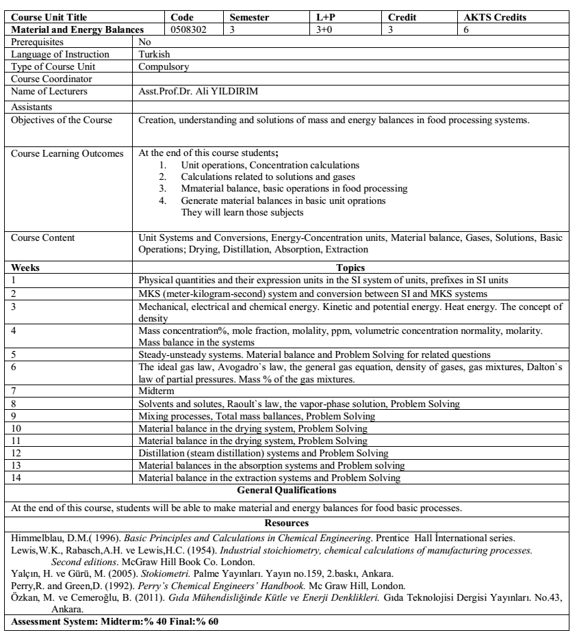

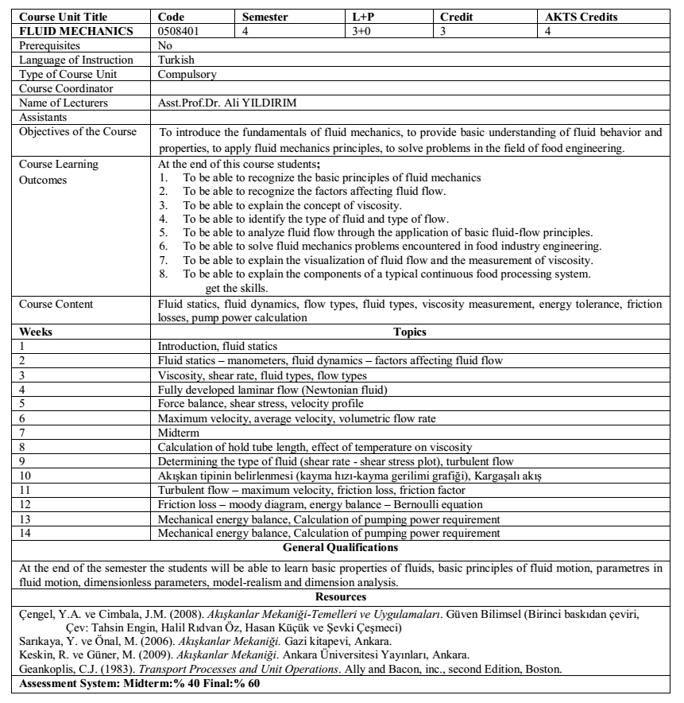

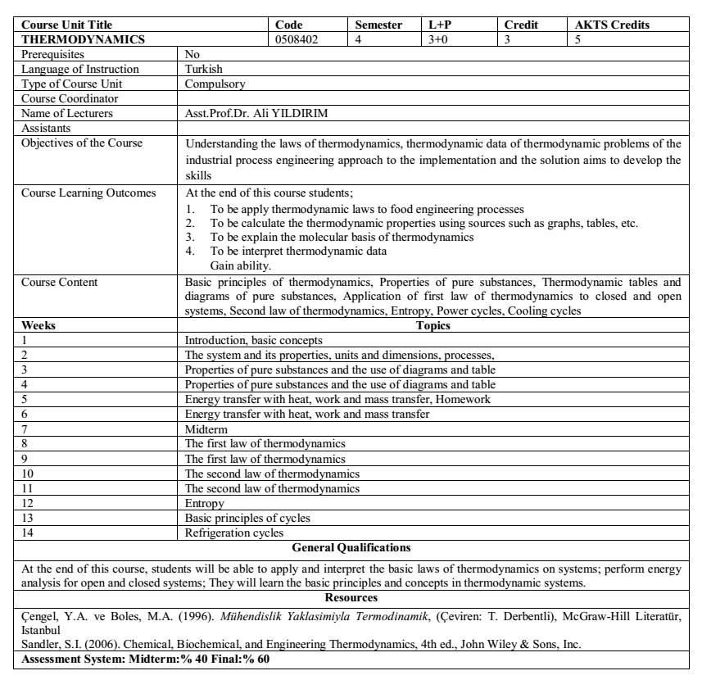

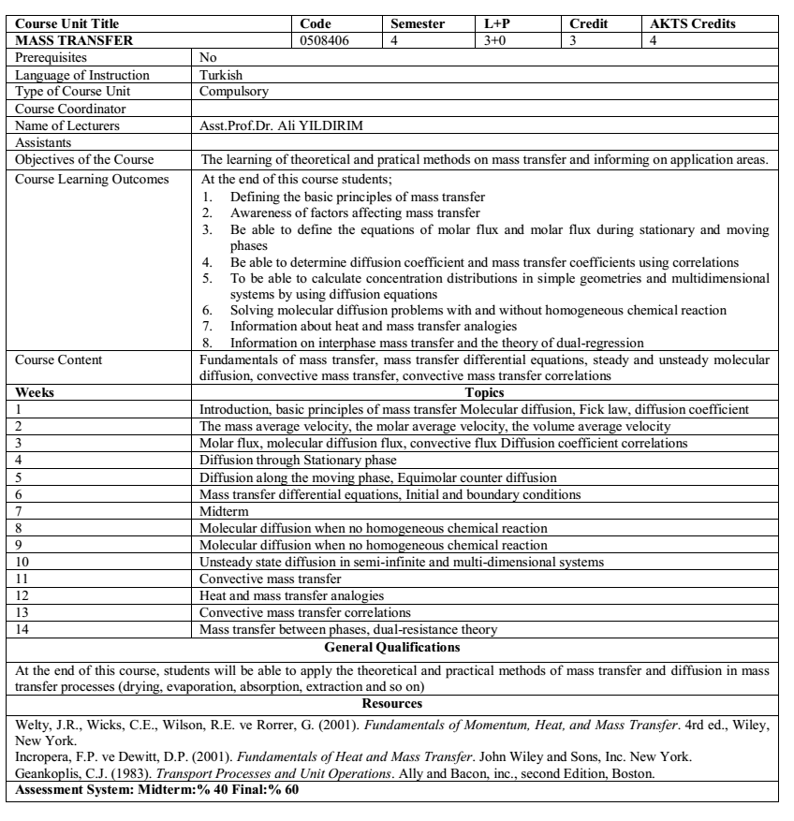

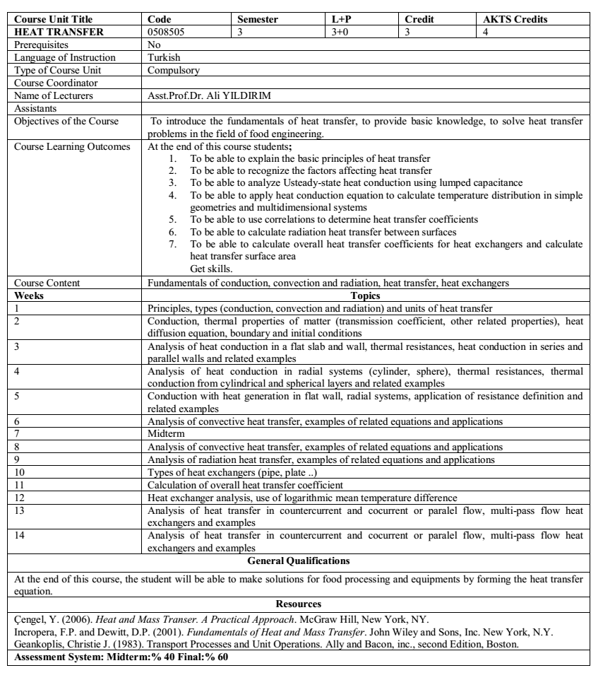

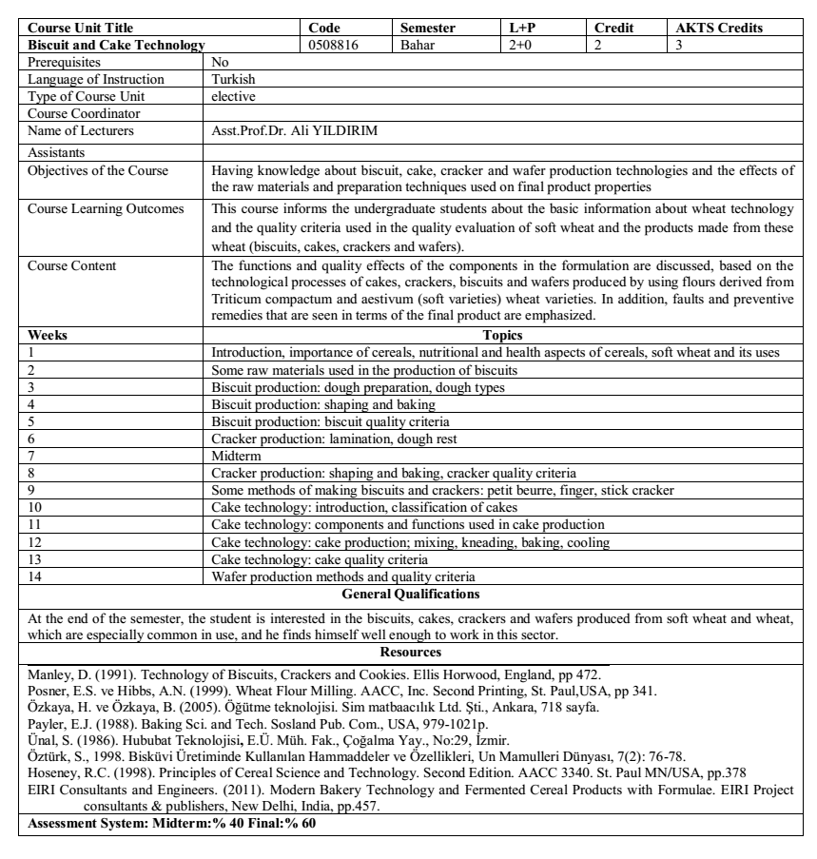

|  |  |  |  |  |  |  |
| --- | --- | --- | --- | --- | --- | --- |
| **Course Name** | | **Code** | **Semester** | **T+U** | **Credit** | **AKTS** |
| **Analytical chemistry** | | 0508201 | 2 (Spring) | 4+0 | 4 | 5 |
| **Prequisites** |  | | | | | |
| **Course Language** | Turkish | | | | | |
| **Course Type** | Compulsory | | | | | |
| **Course Coordinator** | Yrd. Doç. Dr. Yasin YAKAR | | | | | |
| **Instructor (s)** | Yrd. Doç. Dr. Yasin YAKAR | | | | | |
| **Course Assistant** |  | | | | | |
| **Course objective** | The aim of the course is to teach the basic concepts of analytical chemistry, the theoretical and practical knowledge and calculations related to chemical analysis. | | | | | |
| **Learning Outcomes** | |  | | --- | | Student, at the end of this course;   1. Will have enough knowledge about basic concepts of analytical chemistry. 2. Will be able to evaluate analytical data statistically. 3. Will be able to evaluate the sources of random errors in chemical analysis and the effects on chemical analysis results. 4. Will be able to control the quality of the experimental measurements 5. Will be able to evaluate the methods of gravimetric analysis. 6. Will be able to interpret the methods of volumetric analysis. 7. The aqueous solution will be able to interpret the information about the chemistry. 8. May have knowledge about acids and bases. 9. Learn basic information about electrochemistry. | | | | | | |
| **Course Content** | |  | | --- | | Basic concepts of analytical chemistry, Statistical evaluation of analytical data, Errors in chemical analysis, Solution preparation, Gravimetric and volumetric analysis methods, Aqueous solution chemistry, Acid and bases, Introduction to electrochemistry | | | | | | |
| **Week** | **Topics** | | | | | |
| 1 | Basic Concepts in Analytical Chemistry | | | | | |
| 2 | Errors in Chemical Analysis | | | | | |
| 3 | Statistical Evaluation of Analytical Data | | | | | |
| 4 | Preparation of Solution | | | | | |
| 5 | Separation and Purification Techniques | | | | | |
| 6 | Separation and Purification Techniques | | | | | |
| 7 | Midterm | | | | | |
| 8 | Gravimetric Analysis Methods | | | | | |
| 9 | Volumetric Analysis Methods | | | | | |
| 10 | Volumetric Analysis Methods | | | | | |
| 11 | Aqueous Solvents and Chemical Balance | | | | | |
| 12 | Aqueous Solvents and Chemical Balance | | | | | |
| 13 | Acids and Bases | | | | | |
| 14 | Introduction to Electrochemistry | | | | | |
|  | | | | | | |
|  | | | | | | |
| **References** | | | | | | |
| * DOUGLAS. A. SKOOG, DONALD M.WEST, F.JAMES HOLLER 2007; Basic Principles of Analytical Chemistry, Turkish Translation Ed. Esma KILIÇ, Hamza YILMAZ, 8th edition, Bilim Publishing, Ankara. * EMRE DOLEN 2002. Introduction to Analytical Chemistry, Marmara Univ. Publications, Istanbul. | | | | | | |
| **Assessment: Midterm exam: 40% Final exam: 60%** | | | | | | |

|  |  |  |  |  |  |  |
| --- | --- | --- | --- | --- | --- | --- |
| **Course Unit Title** | | **Code** | **Semester** | **L+P** | **Credit** | **AKTS Credits** |
| **Reaction Kinetics** | | 0508308 | 3 | 2+0 | 2 | 3 |
| Prerequisites | No | | | | | |
| Language of Instruction | Turkish | | | | | |
| Type of Course Unit | Elective | | | | | |
| Course Coordinator | Prof. Dr. A. Ferit ATASOY | | | | | |
| Name of Lecturers | Prof. Dr. A. Ferit ATASOY | | | | | |
| Assistants |  | | | | | |
| Objectives of the Course | Aim of the course is to learn the principles and applications of reaction kinetics and mathematical models describing the processes to undergraduate students. | | | | | |
| Course Learning Outcomes | At the end of this course students**;**   1. Determine the reaction order (n) and rate (k) 2. Calculate the concentration of reactions using reaction rate and order. 3. Determine Ea, Q10, z and D value | | | | | |
| Course Content | Transfer of experimental data to the graph, Reaction kinetics, Reaction orders, Zero order, first and second order reactions, determination and calculations of reactions order and rate. | | | | | |
| **Weeks** | **Topics** | | | | | |
| 1 | Dependent and independent variables, linear equations, linearization of nonlinear equations | | | | | |
| 2 | Linear regression, graphic papers | | | | | |
| 3 | Chemical reaction mechanism, Chemical reaction rate. | | | | | |
| 4 | The relationship between concentration and time, factors affecting reaction rate | | | | | |
| 5 | Expression and Mathematical writing of reaction order in reactions. | | | | | |
| 6 | Zero order reactions | | | | | |
| 7 | Midterm | | | | | |
| 8 | First order reactions | | | | | |
| 9 | Second order reactions | | | | | |
| 10 | Pseudo-first order reactions | | | | | |
| 11 | Collision theory | | | | | |
| 12 | Half-life time (t1/2) and decimal reduction time (D) | | | | | |
| 13 | Activation energy | | | | | |
| 14 | Z and Q10, and General review of courses | | | | | |
| **General Qualifications** | | | | | | |
| At the end of this course, students will be able to make reaction order and rate. | | | | | | |
| **Resources** | | | | | | |
| Van Bookel, M. A. J. S, (2009). Kinetic Modeling of Reactions in Foods, 788 s.  Özkan M., Cemeroğlu B., Toklucu S. K., (2010). Gıda Mühendisliğinde reaksiyon kinetiği, 174 s.  Levenspiel, O, (1972). Chemical Reaction Engineering 578 s.  Toledo, R.T., (1994). Fundementals of Food Process Engineering | | | | | | |
| **Assessment System: Midterm:% 40 Final:% 60** | | | | | | |

|  |  |  |  |  |  |  |
| --- | --- | --- | --- | --- | --- | --- |
| **Course Unit Title** | | **Code** | **Semester** | **L+P** | **Credit** | **AKTS Credits** |
| **Shelf life and Measuring the shelf life** | | 0508716 | 7 | 2+0 | 2 | 3 |
| Prerequisites | No | | | | | |
| Language of Instruction | Turkish | | | | | |
| Type of Course Unit | Elective | | | | | |
| Course Coordinator | Prof. Dr. A. Ferit ATASOY | | | | | |
| Name of Lecturers | Prof. Dr. A. Ferit ATASOY | | | | | |
| Assistants |  | | | | | |
| Objectives of the Course | Aim of the course is to determine the shelf life by learning the principles of deterioration of food and new food formulations. | | | | | |
| Course Learning Outcomes | At the end of this course students**;**   1. Understand the realtionship between food and food deterioration. 2. Understand the realtionship between food properties and food deterioration mechanisms. 3. Determine the shelf life of foods different methods. | | | | | |
| Course Content | Shelf life and basic concenpts; Food deteriorations mechanisms and factors; physical, chemical, microbiological and sensory factors affecting the shelf life; shelf life determination methods; Determination of shelf life by accelerated method | | | | | |
| **Weeks** | **Topics** | | | | | |
| 1 | Introduction to shelf life | | | | | |
| 2 | Factors affecting shelf-life and spoilage | | | | | |
| 3 | Moisture and food stability | | | | | |
| 4 | Temperature and food stability | | | | | |
| 5 | Physical factors affecting the shelf life | | | | | |
| 6 | Microbiological deterioration and shlef life | | | | | |
| 7 | Midterm | | | | | |
| 8 | Short shelf life products and properties | | | | | |
| 9 | Long shelf life products and properties | | | | | |
| 10 | Shelf life and Detecting spoilage in foods | | | | | |
| 11 | Shelf-life testing | | | | | |
| 12 | Accelerated shelf-life tests | | | | | |
| 13 | Determination of shelf life by lipid oxidation | | | | | |
| 14 | General review of courses | | | | | |
| **General Qualifications** | | | | | | |
| At the end of this course, students will be able to learn and determine the shelf life of foods. | | | | | | |
| **Resources** | | | | | | |
| Stele, R. (2000). Understnading and measuring the shelf life. 424 s.  Mann, D. (2002). Food Industry Series: Shelf Life, 128 s.  Labuza T. P., (1992).Shelf Life dating of Foods. 525 s. | | | | | | |
| **Assessment System: Midterm:% 40 Final:% 60** | | | | | | |

|  |  |  |  |  |  |  |
| --- | --- | --- | --- | --- | --- | --- |
| **Course Unit Title** | | **Code** | **Semester** | **L+P** | **Credit** | **AKTS Credits** |
| **Process Control** | | 0508801 | 8 | 3+0 | 3 | 6 |
| Prerequisites | No | | | | | |
| Language of Instruction | Turkish | | | | | |
| Type of Course Unit | Compulsory | | | | | |
| Course Coordinator | Prof. Dr. A. Ferit ATASOY | | | | | |
| Name of Lecturers | Prof. Dr. A. Ferit ATASOY | | | | | |
| Assistants |  | | | | | |
| Objectives of the Course | Aim of the course is to determine the necessary strategies and strategies to control the processes in food industry. | | | | | |
| Course Learning Outcomes | At the end of this course students**;**   1. Learn the differences between feed back and feed control strategies. 2. Determine the characteristics of proces in food industry. 3. Follow the change of one or more variables in proces. 4. Determine the appropriate control mode. | | | | | |
| Course Content | Important Terms and the Objective of Process Control; Control Strategies; Mathematical modeling Transfer Functions and Block Diagrams; First-Order Dynamic Systems; Higher-Order Dynamic Systems; Process Conrol Modes | | | | | |
| **Weeks** | **Topics** | | | | | |
| 1 | Process, process variables and automatic process control | | | | | |
| 2 | Feedback Control Strategies | | | | | |
| 3 | Feed forward Control Strategies | | | | | |
| 4 | Process characteristics and dead time | | | | | |
| 5 | Mathematical modeling Transfer Functions and Block Diagrams | | | | | |
| 6 | Mathematical modeling Transfer Functions and Block Diagrams | | | | | |
| 7 | Midterm | | | | | |
| 8 | Matematiksel modelleme, transfer fonksiyonları ve blok diyagramlar | | | | | |
| 9 | Noninteracting process | | | | | |
| 10 | Interacting process | | | | | |
| 11 | Solved examples with Interacting and Noninteracting process | | | | | |
| 12 | Higher-Order Dynamic Systems | | | | | |
| 13 | On-off, Proportional (P) and Integral (I) control modes | | | | | |
| 14 | Proportional-integral (PI), Proportional-integral-differantial (PID) control modes | | | | | |
| **General Qualifications** | | | | | | |
| At the end of this course, students will be able to control the food process. | | | | | | |
| **Resources** | | | | | | |
| Barlos A. Smith, Armando B. Corripio, (1997). Principles and Practice of Automatic Process Control, 763 s.  Toledo, R.T. (1994). Fundementals of Food Process Engineering, 525 s. | | | | | | |
| **Assessment System: Midterm:% 40 Final:% 60** | | | | | | |

|  |  |  |  |  |  |  |
| --- | --- | --- | --- | --- | --- | --- |
| **Dersin Adı** | | **Kodu** | **Yarıyılı** | **T+U** | **Kredisi** | **AKTS** |
| **Food Toxicology** | | 0611831 | 8(spring) | 2+0 | 2 | 3 |
| **Prequisites** |  | | | | | |
| **Course Language** | Turkish | | | | | |
| **Course Type** | Compulsory | | | | | |
| **Course Coordinator** | Yrd. Doç. Dr. Yasin YAKAR | | | | | |
| **Instructor (s)** | Yrd. Doç. Dr. Yasin YAKAR | | | | | |
| **Course Assistant** |  | | | | | |
| **Course objective** | The aim of the course,   1. To give information about natural toxic compounds and contamination factors in foods. 2. To elaborate on the toxic compounds that occur during environmental, chemical contamination, pesticide residues, metal residues, storage and processing of food. 3. To give information about the effects of toxic compounds on health and legal limitations. | | | | | |
| **Learning Outcomes** | Student, at the end of this course;   1. Will learn the basic concepts of food toxicology, 2. Will have detailed information about the toxic compounds from different sources,  |  | | --- | | 1. Will have information about legal restrictions. | | | | | | |
| **Course Content** | |  | | --- | | Definition of toxic food components and factors affecting toxicity; Gıda Foodborne microbial poisoning; Toxic compounds found naturally in foods; Pesticides and veterinary drugs; Food additives; Heavy metals and other environmental contaminants; Irradiation of food; Toxic compounds formed during the processing of food; Reliability of food packaging materials; National and international regulations on toxicological evaluations. | | | | | | |
| **Week** | **Topics** | | | | | |
| 1 | General information about toxicology and toxins. | | | | | |
| 2 | Propagation and excretion of toxins in the body | | | | | |
| 3 | Foodborne poisoning | | | | | |
| 4 | Herbal toxins | | | | | |
| 5 | Bacterial toxins | | | | | |
| 6 | Pesticides | | | | | |
| 7 | Midterm | | | | | |
| 8 | Radioactive contaminants | | | | | |
| 9 | Heavy metal contamination | | | | | |
| 10 | Veterinary drugs and hormones | | | | | |
| 11 | Toxins formed during the storage of food | | | | | |
| 12 | Toxins formed during the processing of food | | | | | |
| 13 | Tests used in toxicological evaluations of food | | | | | |
| 14 | National and international regulations on toxicological evaluations | | | | | |
|  | | | | | | |
|  | | | | | | |
| **References** | | | | | | |
| * Nevin VURAL, 2005. Toxicology. Ankara Univ. Publications, Ankara. * Aylin AYAZ and Mine YURTTAGUL, 2008. Toxic Items in Foods I and II. Ministry of Health Publications, Ankara. | | | | | | |
| **Assessment: Midterm exam: 40% Final exam: 60%** | | | | | | |

|  |  |  |  |  |  |  |
| --- | --- | --- | --- | --- | --- | --- |
| **Dersin Adı** | | **Kodu** | **Yarıyılı** | **T+U** | **Kredisi** | **AKTS** |
| Gıda Mikrobiyolojisi I | | 0508503 | Autumn | 3+2 | 4 | 5 |
| **Ön koşul Dersler** |  | | | | | |
| **Dersin Dili** | Turkish | | | | | |
| **Dersin Türü** | Obligatory | | | | | |
| **Dersin Koordinatörü** |  | | | | | |
| **Dersi Veren** | Prof. Dr. M.Serdar AKIN-Res.As. Büşra GÖNCÜ | | | | | |
| **Dersin Yardımcıları** |  | | | | | |
| **Dersin Amacı** | 1- Deterioration factors in raw and processed food.  2- To inform about food infections and poisonings that directly affect human health.  3- To teach methods of prevention of food diseases and deterioration in food. | | | | | |
| **Dersin Öğrenme Çıktıları** | 1- Learning of important bacterial yeast and mold species in Gıdalard and getting information about control,  2- Learning microbiological risks and elimination while designing new food. | | | | | |
| **Dersin İçeriği** |  | | | | | |
| **Haftalar** |  | | | | | |
| 1 | The topics of food microbiology, the phenomenon of deterioration in food, important bacterial, mold and yeast strains in food. | | | | | |
| 2 | Important bacterial groups in food microbiology (Acetics, proteolitics, lipolitics, saccharolytics, pectinolytics, thermophiles, thermodurics, psychrotrophs, halophiles, osmophilic or saccharophilic bacteria, pigmented bacteria, ropiners, gassers, coliform and faecal coliform group). | | | | | |
| 3 | Sources of contamination | | | | | |
| 4 | Internal and external factors affecting the deterioration of food | | | | | |
| 5 | Chemical changes caused by microbial degradation of food | | | | | |
| 6 | Food preservation methods | | | | | |
| 7 | **Midterm** | | | | | |
| 8 | Food preservation methods | | | | | |
| 9 | Microbial deterioration and preventive methods in cereal and cereal products | | | | | |
| 10 | Microbial deterioration and preventive measures in vegetable and vegetable products. Cooling, freezing and drying. | | | | | |
| 11 | Microbial deterioration and measures to be taken in fruit and fruit products. Cooling of fruits, freezing and canning, pulp, marmalade and jelly processing and possible microbial risks. | | | | | |
| 12 | Degradation of meat under aerobic and anaerobic conditions and conditions of preservation of meat and products. | | | | | |
| 13 | Deterioration of milk and dairy products and preservation methods | | | | | |
| 14 | Bacterial food poisoning, mycotoxins and preventive methods. | | | | | |
| **Genel Yeterlilikler** | | | | | | |
| Students are informed about microbial safety in raw and processed foods and assessing microbial risks while developing new products. | | | | | | |
| **Kaynaklar** | | | | | | |
| Özçelik, S., *Gıda Mikrobiyolojisi*,(2004) Süleyman Demirel Üni., Ziraat Fak., Yayın No:6, Ders Kitapları No:6, Isparta.  Ünlütürk, A. ve Turantaş, F.(Ed.),(1998), *Gıda Mikrobiyolojisi*, Mengi Tan Basımevi,1. Baskı, Çınarlı-İzmir.  Erkmen, O.(Ed.),(2011), *Gıda Mikrobiyolojisi*, Efil Yayınevi, 3. Baskı, Ankara.  Şahin, İ. Ve Başoğlu, F.(2011), *Gıda Mikrobiyolojisi*, Dora Basım Yayın Dağıtım Ltd.Şti., 2.Baskı, Bursa. | | | | | | |
| **Değerlendirme Sistemi: Ara sınav:% 40 Final:% 60** | | | | | | |

|  |  |  |  |  |  |  |
| --- | --- | --- | --- | --- | --- | --- |
| **Course title** | | **Code** | **Semester** | **T+U** | **Credits** | **AKTS** |
| **Meat and Products Technology** | | 0611737 | 7 (Autumn) | 2+0 | 2 | 3 |
| **Prequisites** |  | | | | | |
| **Course Language** | Turkish | | | | | |
| **Course Type** | Elective | | | | | |
| **Course Coordinator** | Yrd. Doç. Dr. Yasin YAKAR | | | | | |
| **Instructor (s)** | Yrd. Doç. Dr. Yasin YAKAR, Yrd. Doç. Dr. Eyyüp KARAOĞUL | | | | | |
| **Course Assistant** |  | | | | | |
| **Course objective** | Instruct muscle and meat structure, composition and meat quality parameters, Demonstrate basic preservation methods and processing technologies of meat products | | | | | |
| **Learning Outcomes** | 1) Understanding slaughtering and dressing and how meat obtained  2) Understanding skills relating to meat quality  3) Understanding quality properties of meat and meat products  4) Understanding of basic concepts related to meat technology  5) Understanding of processing technologies of meat products | | | | | |
| **Course Content** | |  | | --- | | Meat sources, muscle structure and composition, contraction and relaxation of muscle, slaughter-dressing of livestock and carcass grades, conversion of muscle to meat, fresh meat quality (pH, water holding capacity and colour), principles of meat preservation methods; refrigeration and freezing Technologies, meat processing Technologies; curing, smoking, emulsification, fermentation, canning, restructured meat products, meat packaging technology. | | | | | | |
| **Week** | **Topics:** | | | | | |
| 1 | What is meat? Meat sources and livestocks, importance of meat for nutrition and health | | | | | |
| 2 | Meat sources and introduction of meat animals | | | | | |
| 3 | Histological structure and composition of muscle and associated tissues | | | | | |
| 4 | Contraction and relaxaton of the muscle, | | | | | |
| 5 | Slaughter of livestock, slaughtering methods and their effects on meat quality, | | | | | |
| 6 | Midterm | | | | | |
| 7 | Dressing of carcass and carcass grades | | | | | |
| 8 | Conversion of muscle to meat | | | | | |
| 9 | Fresh meat quality (pH, water holding capacity and colour) | | | | | |
| 10 | Fermented and dried meat (sucuk) processing technology | | | | | |
| 11 | Emulsified meat (sausage) processing technology | | | | | |
| 12 | Smoking of meat and meat products | | | | | |
| 13 | Cured and dried meat (pastırma) processing technology | | | | | |
| 14 | Packaging technology of meat and meat products | | | | | |
| **General Qualifications.** | | | | | | |
|  | | | | | | |
| **References** | | | | | | |
| * Öztan, A. Et Bilimi ve Teknolojisi. TMMOB Gıda Mühendisleri Odası, Ankara, 2005. | | | | | | |
| **Assessment: Midterm exam: 40% Final exam: 60%** | | | | | | |

|  |  |  |  |  |  |  |
| --- | --- | --- | --- | --- | --- | --- |
| **Dersin Adı** | | **Code** | **Semester** | **T+U** | **Credit** | **AKTS** |
| **Statistical Methods in Engineering Studies** | | 0611618 | GÜZ | 2+2 | 2 | 3 |
| **Prequisites** |  | | | | | |
| **Course Language** | Turkish | | | | | |
| **Course Type** | Compulsory | | | | | |
| **Course Coordinator** | Yrd. Doç. Dr. Yasin YAKAR | | | | | |
| **Instructor (s)** | Yrd. Doç. Dr. Yasin YAKAR | | | | | |
| **Course Assistant** |  | | | | | |
| **Course objective** | Giving students the basics of ststistical thinking, giving the ability to apply the statistical language and tools to real life situations, helping students to learn to summarize, display and conduct basic statistical calculations and interpretations. | | | | | |
| **Learning Outcomes** |  | | | | | |
| **Course Content** | |  | | --- | | Data collection, data display and summarization, basic probability calculations, hypothsis testing | | | | | | |
| **Week** | **Topics** | | | | | |
| 1 | Introduction to Probability and Statistics, Basic Concepts | | | | | |
| 2 | Serial types, Arrangement of the data as a simple, frequency and grouped serie | | | | | |
| 3 | Measures of Central Tendency (Arithmetic, Geometric, Harmonic, Quadratic means) | | | | | |
| 4 | Measures of central tendency not sensitive | | | | | |
| 5 | Measures of variability (Sensitive and Non-sensitive) | | | | | |
| 6 | Measures of variability (Sensitive) | | | | | |
| 7 | Ara sınav | | | | | |
| 8 | Standard deviation calculations | | | | | |
| 9 | Display data in charts | | | | | |
| 10 | Probability, Basic Concepts and introduction to probability distributions | | | | | |
| 11 | Continuous and discrete probability Distributions | | | | | |
| 12 | Simple Linear Regression and Correlation | | | | | |
| 13 | Practice | | | | | |
| 14 | Practice | | | | | |
|  | | | | | | |
|  | | | | | | |
| **References:** | | | | | | |
| 1. Özkan Ünver, Hamza Gamgam,“Uygulamalı Temel İstatistiksel Yöntemler”,2008. 2. Vasfi Nadir Tekin,”İstatistiğe giriş”,2008 | | | | | | |
| **Assessment: Midterm exam: 40% Final exam: 60%** | | | | | | |