CURRICULUM VITAE
PERSONAL DATA |  | 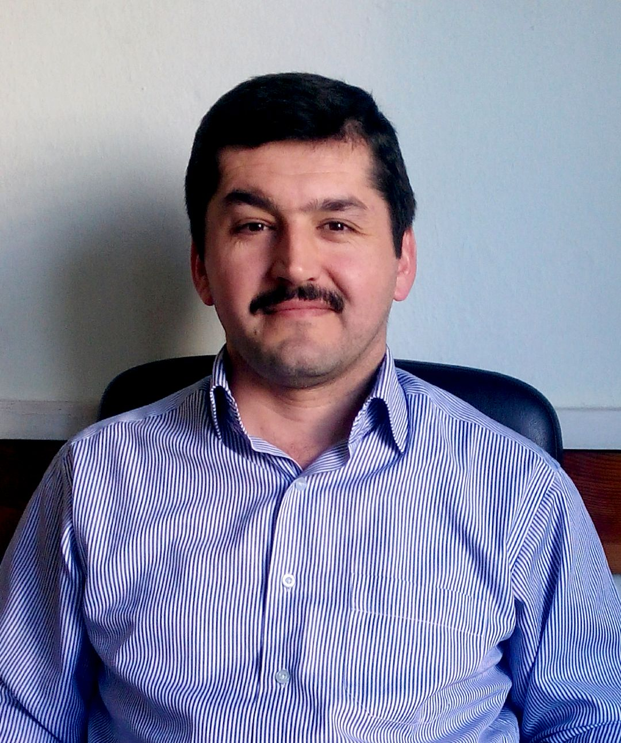
Name | Yrd. Doç. Dr. Yasin YAKAR
Telephone | 1641
E-mail | yakar75@gmail.com  yasinyakar@harran.edu.tr
Date and Place of Birth | Kadirli/1975
Education :
Degree | Department | Institution | Year
PhD | Chemistry | Mustafa Kemal University, Graduate School Of Natural And Applied Sciences | 2014
MS | Chemistry | Harran University,  Graduate School Of Natural And Applied Sciences | 2001
BS | Chemistry | Harran University,  Faculty of Arts and Sciences | 1998
AS | Health Technician | Anadolu University, Open Education Faculty | 1995

Doctorate Thesis:
The Effect of Feedıng with Safflower Seed Added Mixed Feed on the Amount of Conjugate Linoleic Acid, Total Protein and Cholesterol in Chicken Meat and Eggs
(Thesis Advisor: Yrd. Doç. Dr. Yener TEKELİ).
Master Thesis:
The Analysis of Electron Transfer Mechanism for Aniline -4-Sulfonic Acid by Potentiometric Method. (Thesis Advisor: Yrd. Doç. Dr. Mehmet ASLANOĞLU).
Görevler:
Academic / Administrative Tasks | Institution | Year
Assistant Professor | Harran University, Faculty of Engineering, Department of Food Engineering | 2016-
Chemist | Ministry of Food, Agriculture and Livestock  Hatay Food Control Laboratory Directorate | 2001 – 2016
Laborant | Ministry of Food, Agriculture and Livestock  Şanlıurfa Food Control Laboratory Directorate | 1994 – 2001
Laborant | Ministry of Food, Agriculture and Livestock  Manisa Poultry Research Institute | 1992 - 1994
Uzmanlık Alanları :
- HPLC, GC-FID, LC-MS/MS, ICP-OES, Spektrofotometre).
- Physical, chemical, additive and mineral analyses in foods.
- antibiotic and pesticide residues analysis.
- Quality and purity analyzes in olive oil.
- Accreditation, method validation and measurement uncertainty.

PUBLICATIONS

A. SCI
A1. Kasumov, V.T., Taş E., Yakar Y., Köksal F. and Köşeoğlu R.,”Spectroscopic Studies on Bis(3,5-di-tert-butyl-1,2-benzoquinone 1-oximo)coppr(II) and its Mixed-Ligand Complexes. Strong Copper(II)-Radical Ferromagnetic Couplings”. Z. Naturforsch., 57b:495-502 (2002).

A2. Eştürk O., Yakar Y. and Ayhan Z. “Pesticide Residue Analysis in Parsley, Lettuce and Spinach by LC-MS/MS” Journal of Food Science and Technology, 51(3):458-466 (2014).

A3. Erden E.S., Motor S., Üstün İ., Demirköse M., Yüksel R., Okur R., Oktar S., Yakar Y., Sungur Ş., Gökce C., “Investigation of Bisphenol A as an endocrine disruptor, total thiol, malondialdehyde, and C-reactive protein levels in chronic obstructive pulmonary disease”. Eur. Rev. for Medi. and Pharmacol. Sci., 18(22):3477-3483 (2014).

A4. Eyduran E., Ser G., Cinli H., Tirink C., Yakar Y., Duru M., Javed Y. and Tariq M.M. “Analysis of Random Intercept and Slope Model (RISM) for Data of Repeated Measures from Hy-Line White Laying Hens”. Pakistan J. Zool., 48(5):1219-1224 (2016).

B. International Presentations:
B1. Eştürk O., Ayhan Z., Yakar Y. “Pesticide Residue Analysis in Parsley, Lettuce and Spinach by LC-MS/MS”, 1st International Food Congress, Antalya, 2010.

C. National Publications:
C1. Yakar Y., Tekeli Y., Duru M., Danahaliloğlu H., Bucak S. “Effect of Feeding with Safflower Seed Added Mixed Feed on the Fatty Acid Composition in Eggs”. MKÜ Journal of Agricultural Faculty, 19(1):44-55 (2014)

C2. Tekeli Y., Danahaliloğlu H., Yakar Y., Bucak S., Sarıhan E.Ö. “Antioxidant Properties of Saffron (Cracus sativus L.) Grown in Yayladağı and Safranbolu”. MKÜ Journal of Agricultural Faculty, 19(1):11-18 (2014)

C3. METLİ M., YAKAR Y., TEKELİ Y. “Determination of Antibiotic Residues in Chicken Liver by Liquid Chromatography-Tandem Mass Spectrometry”. Adıyaman University Journal of Science, (2015).

D. National Presentations:
D1. Bucak S., Yakar Y., Tekeli Y. “Determination of Pesticide Residues of Pine, Eucalyptus, Flower and Parsley Honeys Produced in Hatay Province by LC-MS / MS.”, Chromatography Congress, Diyarbakır, 2011.

D2. Yakar Y., Sarıgöz A., Metli M., Tekeli Y. “Determination of Pesticide Residues of Some Vegetables Sold in Local Markets in Hatay by LC-MS / MS.”, Chromatography Congress, Diyarbakır, 2011.

D3. Yakar Y., Tekeli, Y., Sarıgöz A., Metli M. “Investigation of Grape Samples Obtained from Local Markets in Hatay for Pesticide Residues”, VI. National Analytical Chemistry Congress, Hatay, 2012.

D4. Yakar Y., Tekeli Y., Sarıgöz A. “Determination of Pesticide Residues by LC-MS / MS in Some Fruits Obtained from Local Markets in Hatay.”, Chromatography Congress, Bursa, 2013

D5. Danahaliloğlu H., Tekeli Y., Güzel Y., Yakar Y., Bucak S. “Investigation of Fatty Acids Composition of Some Verbascum Species”. VII. National Analytical Chemistry Congress, K.Maraş, 2014

D6. Yakar Y., Tekeli Y., Karadeniz H. “Detection of Vegetable Fat in Milk and Dairy Product ”. VII. National Analytical Chemistry Congress, K.Maraş, 2014

D7. Yakar Y. “Eggs With Less Cholesterol” . East Mediterranean Universities Arge Project Market and Project Competition, İskenderun/Hatay, 2014.

D8. Murat METLİ, Yasin YAKAR. “Investigation of Naphthalene in Honey Samples by GC-MS in Hatay”. Chromatography Congress, Uşak, 2015.

D9. Murat METLİ, Yasin YAKAR. “Determination of Benzoic Acid and Sorbic Acid by HPLC-UV in Some Ready-to-eat Foods Sold in Hatay”. Chromatography Congress, Uşak, 2015.

D10. Yasin YAKAR, Murat METLİ. “Investigation of Pesticide Residues in Some Spices by LC-MS / MS”. Chromatography Congress, Uşak, 2015.

D11. Yasin YAKAR, Yener TEKELİ, Metin DURU. “Effect of Feeding with Safflower Seed Added Mixed Feed on the Fatty Acid Composition in Chicken Meat”. Chromatography Congress, Uşak, 2015. (Oral presentation)

D12. Murat METLİ, Yasin YAKAR, Adem SARIGÖZ. “Detection of Naphthalene in Honey by using Gass Chromatography-Mass Spectrometry Following Ultrasound Assisted Solid-Phase Microextraction”. VI. National Veterinary Food Hygiene Congress, Van, 2015. (Oral presentation)

D13. Murat METLİ, Yasin YAKAR, Yener TEKELİ. “Determination of Antibiotic Residues in Chicken Liver by Liquid Chromatography-Tandem Mass Spectrometry”. VI. National Veterinary Food Hygiene Congress, Van, 2015.

